Instruction of
UCANDAS quick operation
Table of Contents
1. Software Operating Environment 。
2. Software Download and Installation 。
2.1 Software Download 2
2.2 Software Installation 2
3. Software Operation 。
3.1 System Settings 3
3.1.1 Read VDM Versions 3
3.1.2 Language 3
3.1.3 Run Mode 3
3.1.4 Unit Selection 3
3.2 Software Management 3
3.2.1 Software Upgrade 3
3.2.2 Version Management 3
3.2.3 Users Information 3
3.3 Car Diagnosis 3
4. Software Update 。
5. Warranty 。

Software Operating Environment
● Hardware requirements: notebook, desktop and PAD, with at least 5G system disk and 1G memory card;
● Supported operating systems: WINDOWS XP SP3, WINDOWS 7 and WINDOWS 8, not WINDOWS RT now;
● Internet requirement: The software needs to be activated online and download via internet, please make sure your network connection is active.
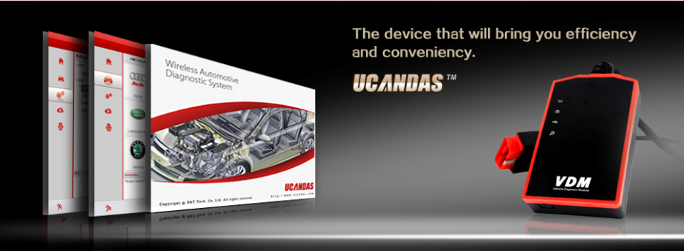

2. Software Download and Installation

2.1 Software Download

Visit http://www.ucandas.com/mod_download-fullist.html to download UCANDAS V3.0 EN.zip software package.

2.2 Software Installation
Unzip UCANDAS V3.0 EN.zip to release two files, setup.exe and UCANDAS_Setup.msi. Choose one of the files to install. Take installation with setup.exe for example. To do this:

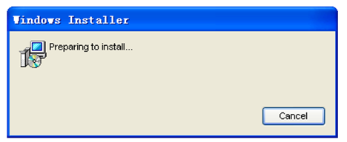

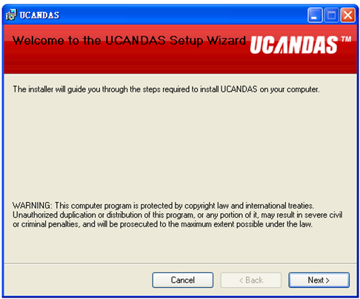

Click “Next”
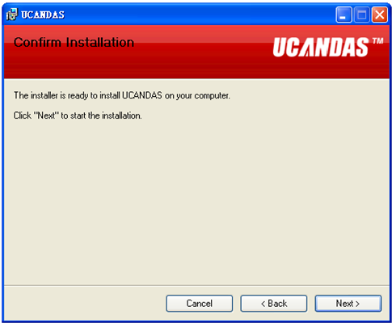

Click “Next”
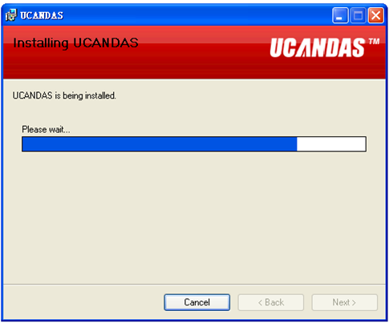
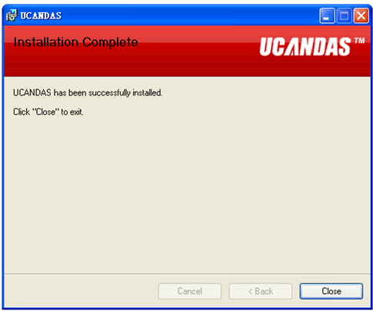
UCANDAS wireless diagnositc system has already installed successfully, while USB driver has not installed yet. Hence, click UCANDAS shortcut on desktop to install USB driver installer step by step. Here is the procedure:
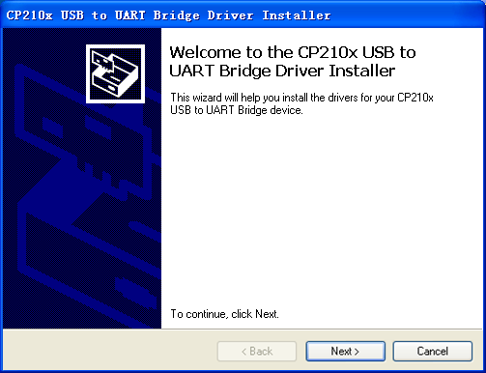

Click “next”
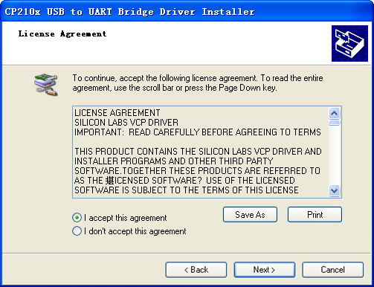

Select “I accept this agreement”, and Click “next”
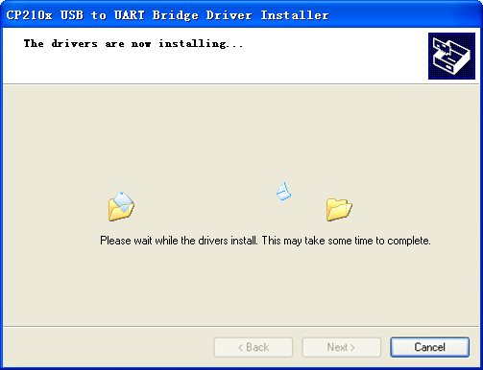
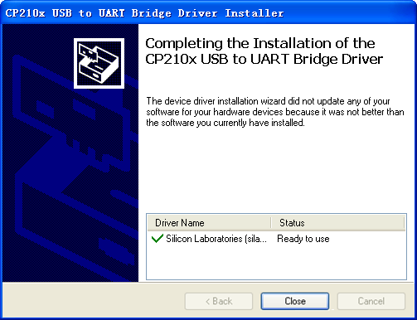

Click “close” and enter into UCANDAS diagnostic system interface, as follows：

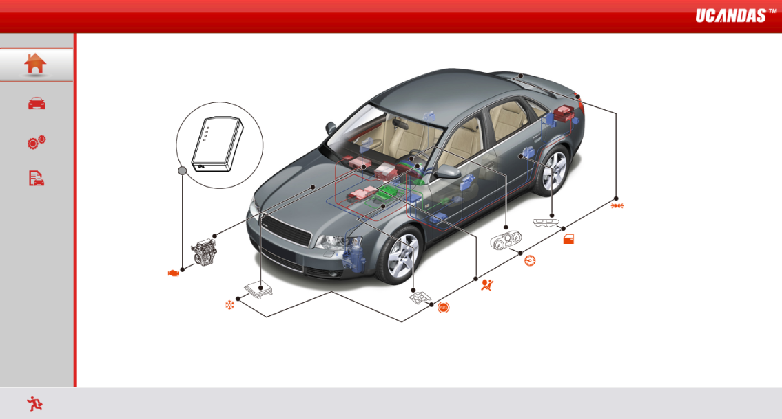

- Software Operation
Running UCANDAS, the main interface shows as picture:
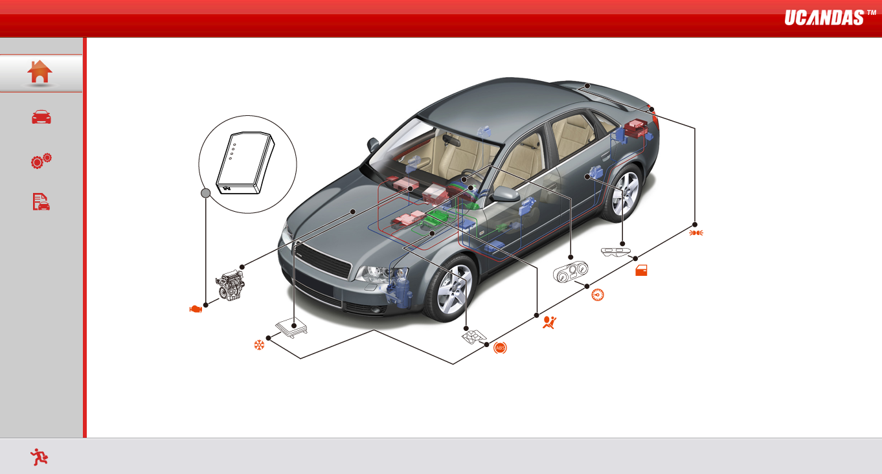
Instructions：
Function Icon | Function Name | Function Description
 | Main interface | The main interface introduces and describes the performance and brand of UCAND
 | Car diagnostic system | The core function of auto wireless diagnostic system: It provides simple but professional auto comprehensive diagnostic functions, including ECU information reading, DTCs analysis, data stream analysis, freeze frame data reading, component execution, programming, matching, setting and anti-theft and etc.
 | System settings | System settings provide multiple functional operation modes, connection methods unit selection, language selection, and so on to enrich users’ experiences.
 | Software management | Software management is used to identify auto diagnostic software’s version to inform users updating software, help users in managing car diagnosis software, register users information to enhance users usage safety, as well as to show users information when print test report
 | Exit | Exit UCANDAS system safely.

3.1 System Settings

3.1.1 Read VDM versions
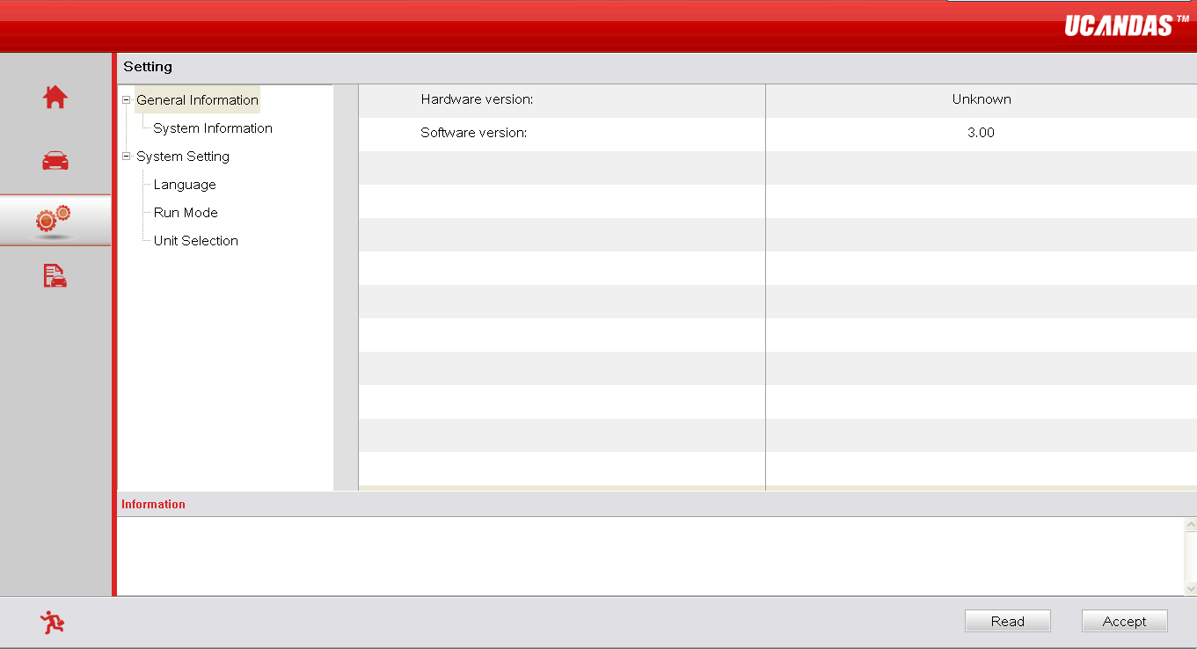

If there is something wrong with USB connection, it will fail to read VDM’s Hardware version, usually shows as “Unknown” or “---”; while if it works normally, it shows hardware version number as following reference picture:
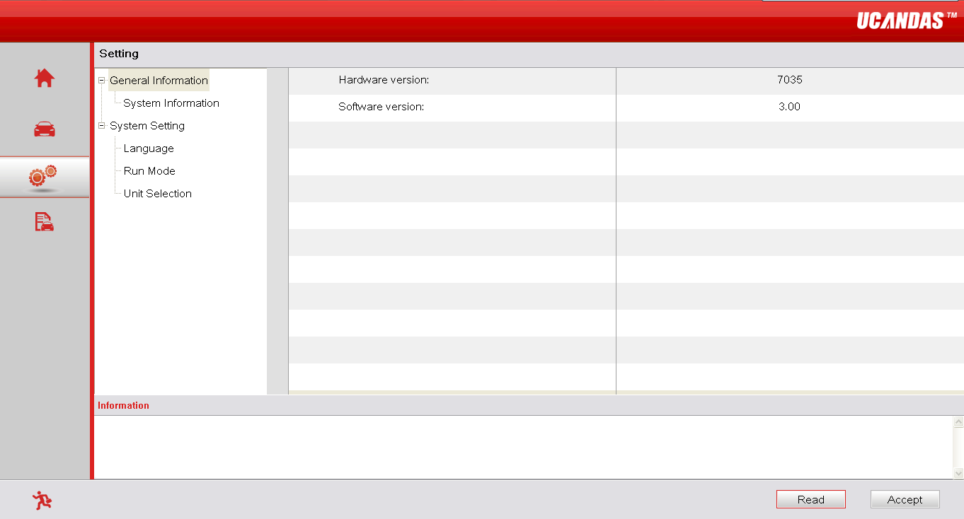

3.1.2 Language
You can change your language setting on UCANDAS, as shown below:

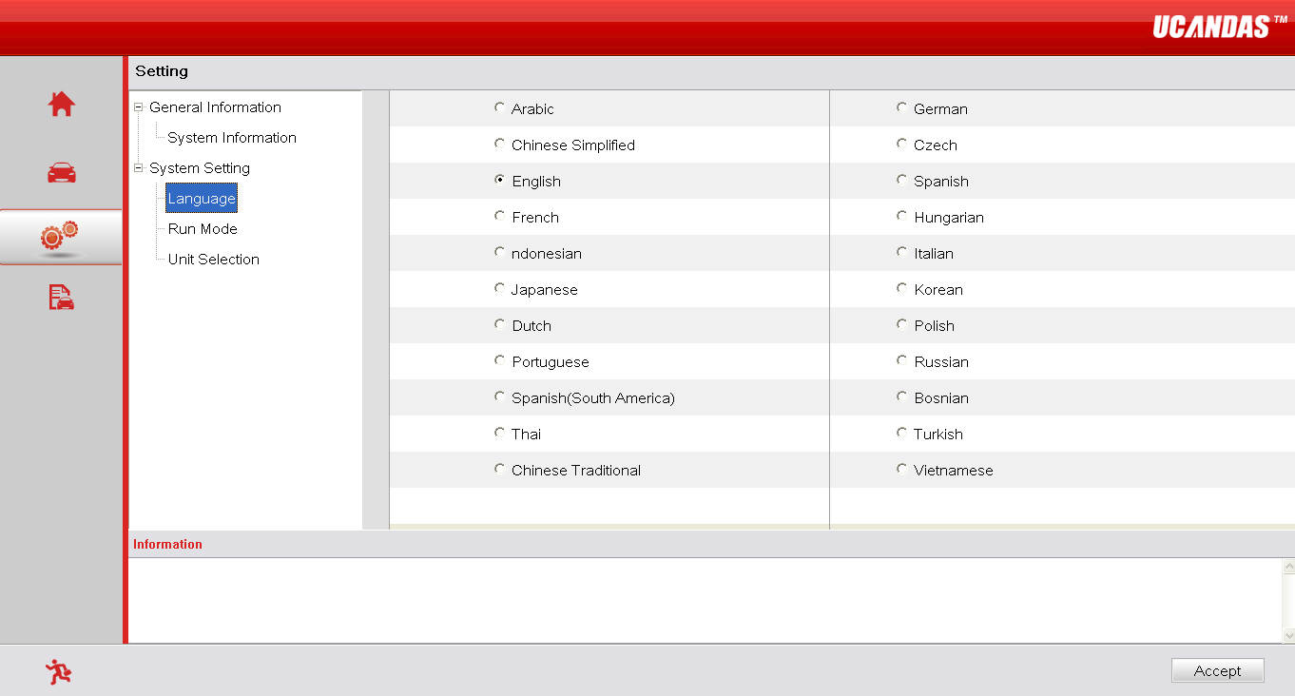
Notice: The default languages will be Chinese and English, if you have not bought a language package.

3.1.3 Run Mode
UCANDAS provides DEMO mode, which enables you to view its full functions without connecting VDM, as shown in picture below:
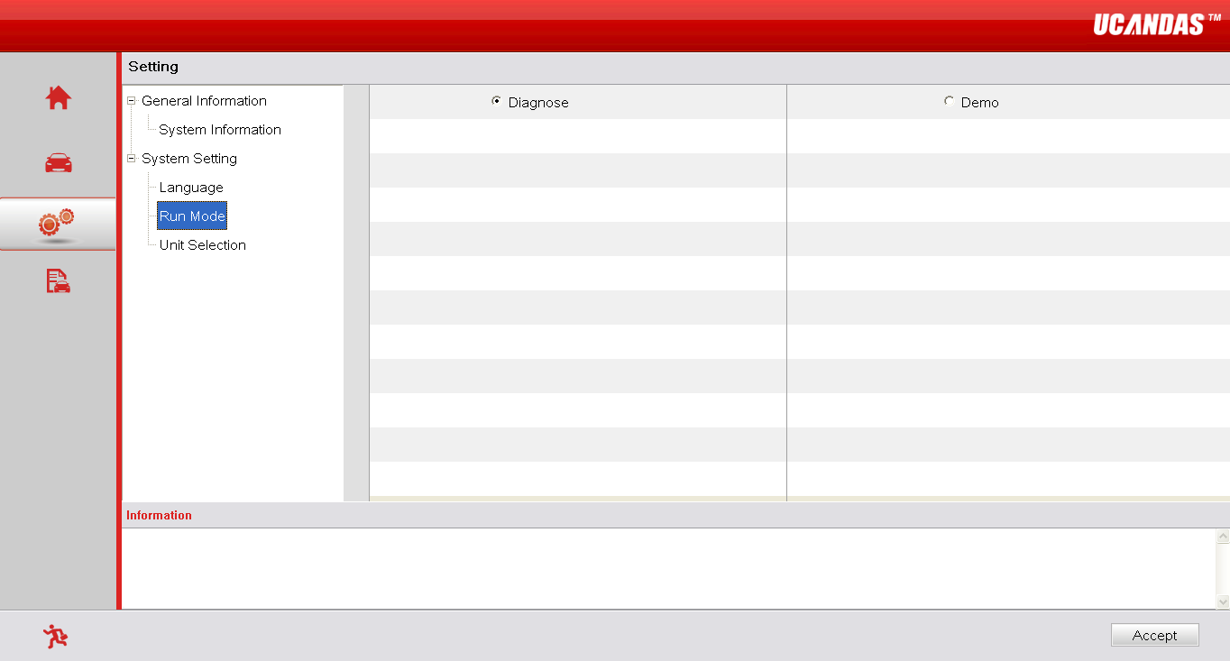

3.1.4 Unit Selection
UCANDAS allows you to choose metric or imperial units of measurement, as shown below:

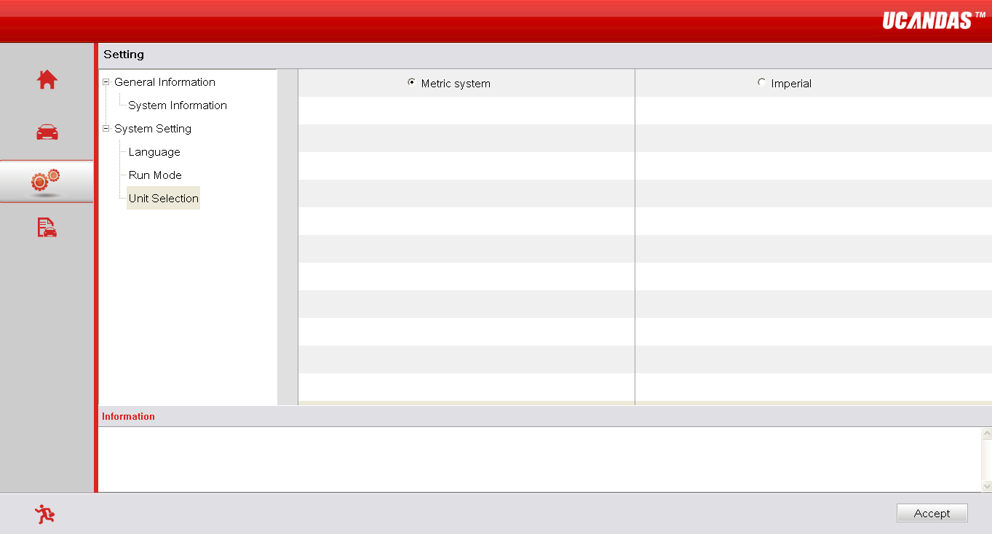

3.2 Software Management

3.2.1 Upgrade
You should connect UCANDAS to a computer via USB connector during software upgrade, as shown below:
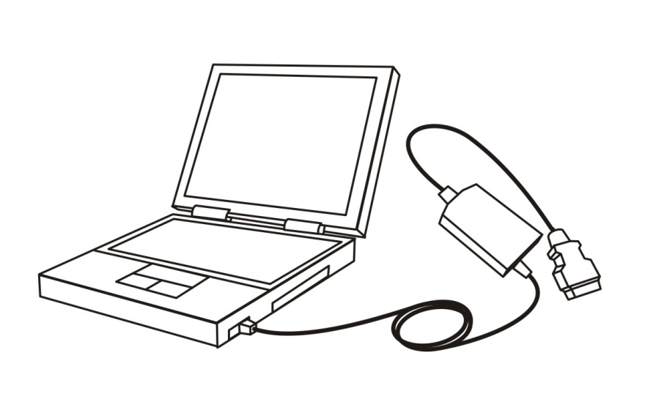
Reread “Hardware version” on VDM to make sure the device works well. If there is something wrong, check cable connection, as shown below:

Choose software version:
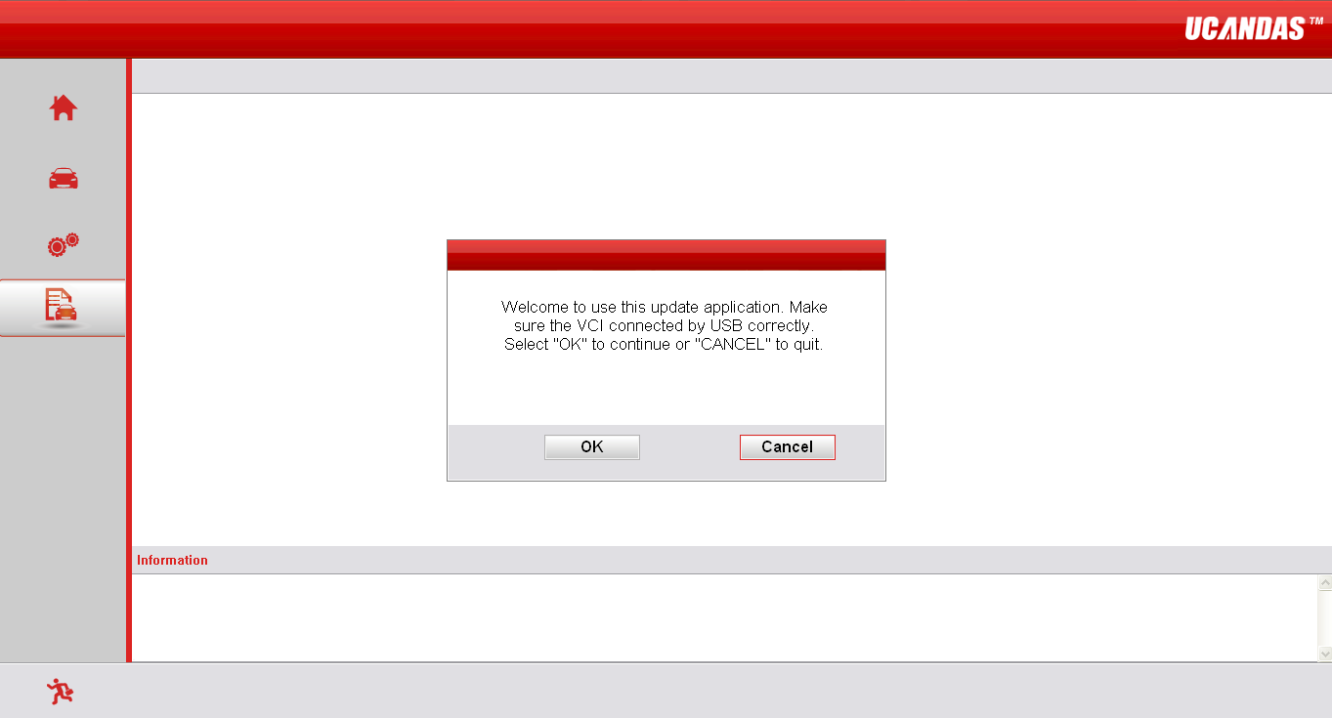

Instructions:
Functional icon | Name | Functional description
 | Software upgrade | Update car make and model recognition software with one click.
 | Car make and model management | Help you to delete software for various car makes according to your car model.
 | Userinfo | Record user’s information, improve efficiency with information sharing, enhance users usage safety and customers can feel easier to complain.

Press “OK” and enter interface of software upgrading, as shown below:
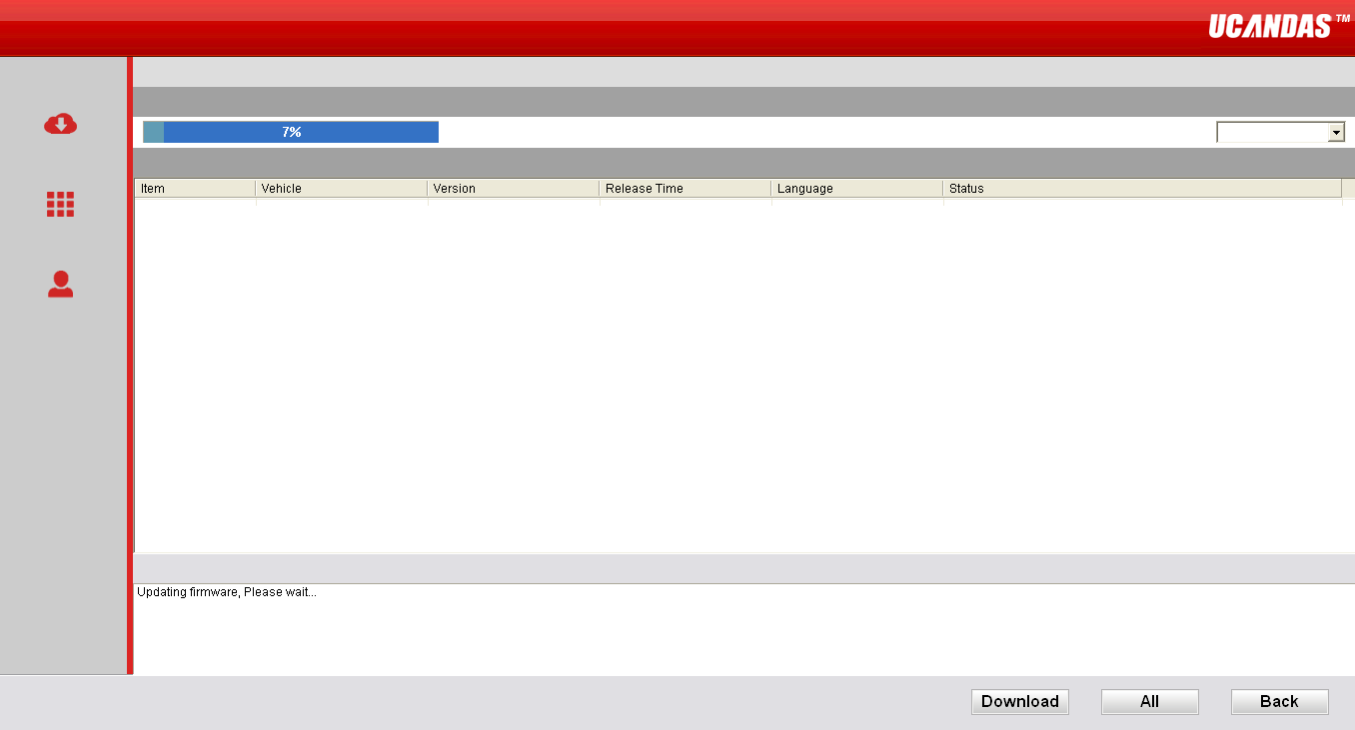

UCANDAS’s software can be upgraded in two ways: Manual Update and One-click Update, as shown below:
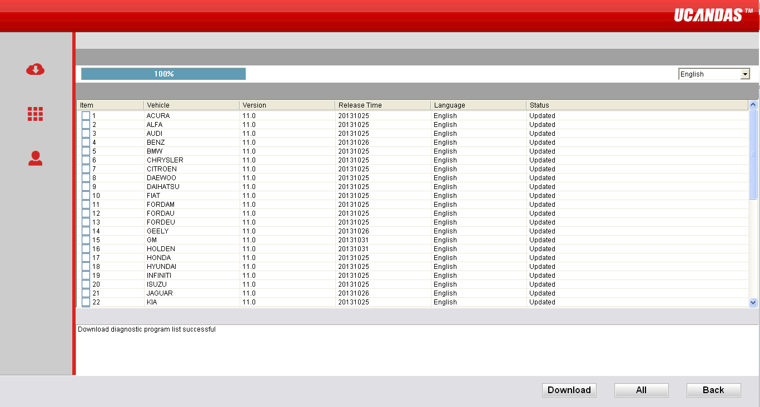

3.2.2 Version Management
Allow you to manage and delete the software versions according to your car model, as shown below:

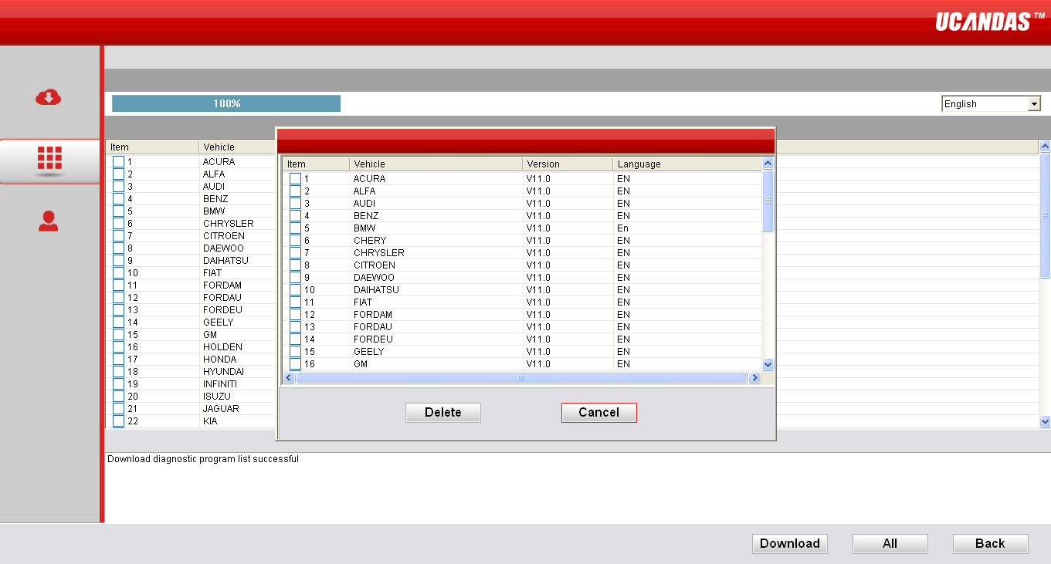

3.2.3 User Information
UCANDAS provides you with complete management of user information. It records basic information, shares manufacturer resources, as well as enhances users’ usage safety, so that customers can feel easier to complain and feedback, as shown below:
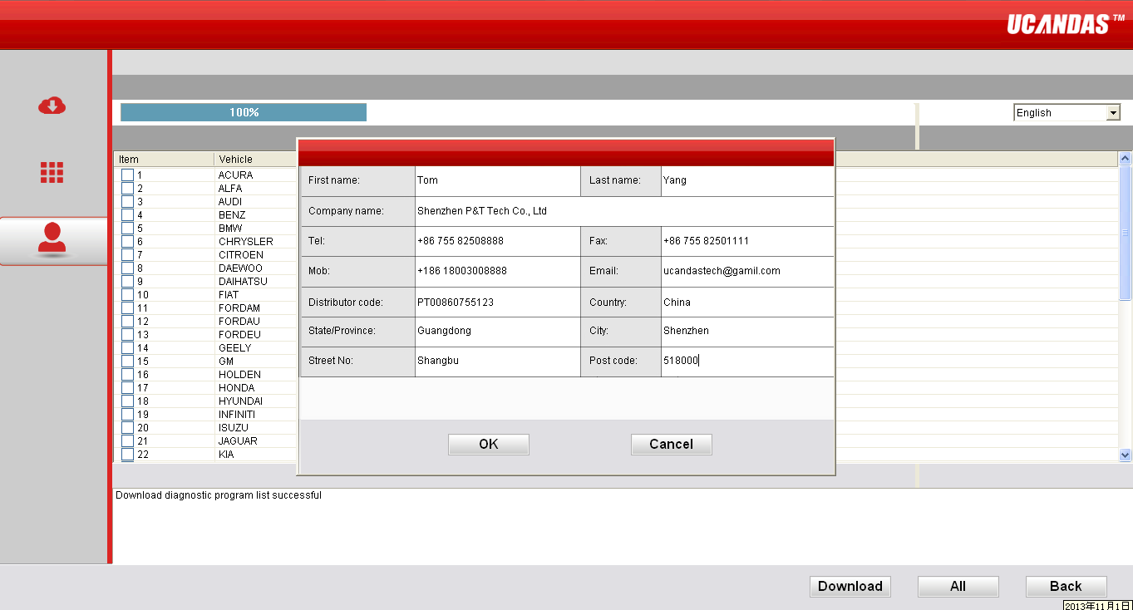

3.3 Car Diagnosis
Please connect VDM to the OBD diagnostic block of the car and the power indicator will then illuminate. The fixed SSID of VDM is UCANDAS. If you fail to connect the device to Wi-Fi, please set it manually. The VDM wireless icon will come on after you successfully connecting it to Wi-Fi. Then start UCANDAS software and click the “car diagnose” icon, as shown below:
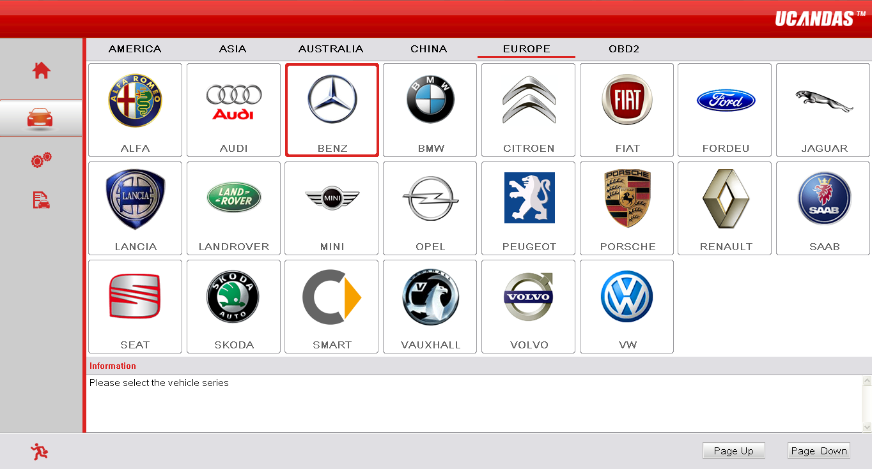

Click the corresponding auto icon, choose software version, and enter car diagnosis interface, as shown below:

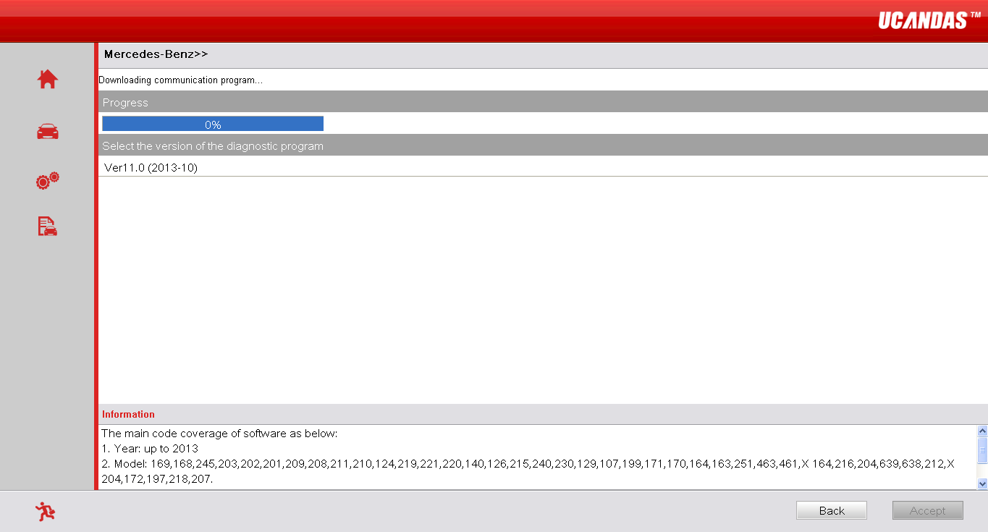

Software Update
Please follow the updating information on our website: www.ucandas.com.

Warranty
UCANDAS software is free updating within 1 year, from the date of online automatically updating.

