Product Feature Introduction

1. Product introduction 3
2. Hardware Feature 4
3. Software Feature 5
3.1 Function Introduction 5
3.2 Software Feature 5
4. Code Coverage Introduction 13
4.1 IDUTEX Store 13
4.2 Diagnosis Service System 14
4.2.2 Heavy-Duty Coverage 14
4.2.3 Ligth-Duty/Car Coverage 16
4.3 Settings 17
4.3.1 System info 17
4.3.2Unit 18
4.3.3 Search Engine 18
4.3.4Run Mode 19
4.3.5OS Versions 20
4.3.6Languages 21
4.3.7About US 23
4.4 Dictionary 23
4.6Example 24
4.6.1 Bluetooth pairing 24
4.6.2 Communication 25
4.6.3 Read ECU Information 27
4.6.4 Read DTCs 28
4.6.5 Erase DTCs 29
4.6.6 Data List 30
4.6.7I/M Readiness 35
4.7 Screenshot 36
4.8 Save 38
4.9 Screen recording 40
4.10 Data Playback 41
4.12Feedback 42
4.13Data Management 43
4.13.1 Image Management 43
4.13.2 APP Management 44
4.13.3 Video Management 45
4.13.4 Report Management 46
4.14 User Management 47
4.15 Quick Support 48
5. Products Website 49
6. Warranty 49

Product introduction
XTUNER CVD-16 is a commercial vehicle and passenger car diagnostic adapter based on android system. This is an electronic device that connects to your truck or your car, fire engine, or motorhome’s on-board computers (ECUs) and transmits information via Bluetooth to the XTUNER CVD-16 application (CVD+OBD+EOBD full brand vehicle, full systems DAS).
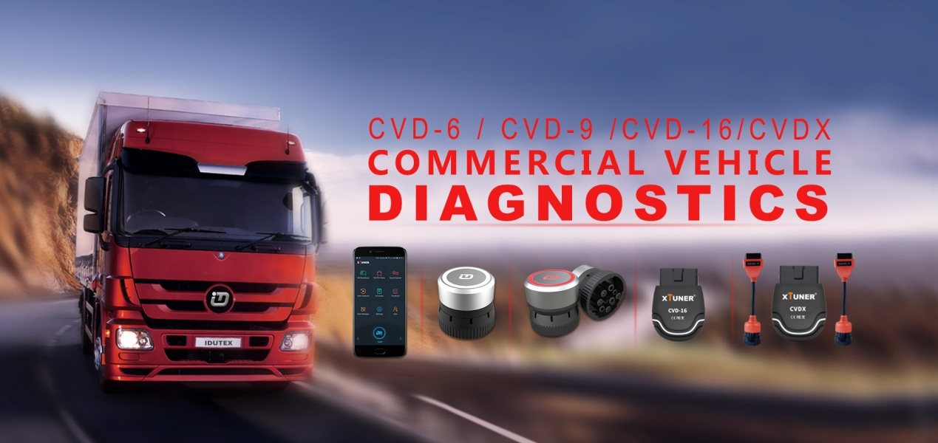
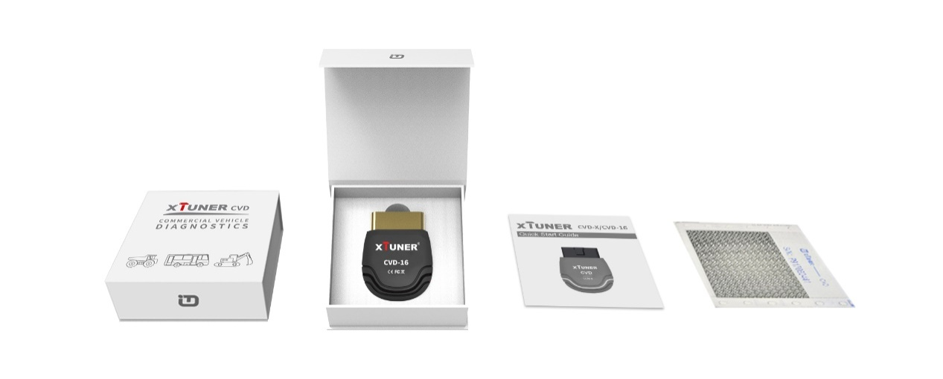
- Hardware Environment:
Memory: more than 1GB
Communication port: Bluetooth
- Software Environment:
Based on Android4.4 above the smart phone system

Hardware Feature
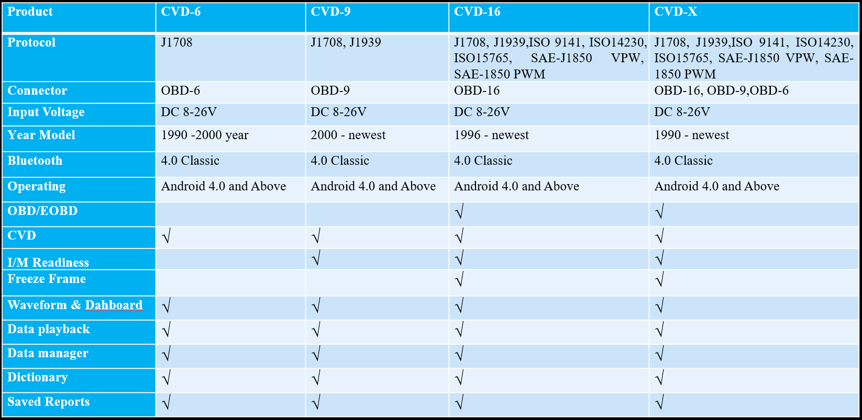
XTUNER VCD product comparison
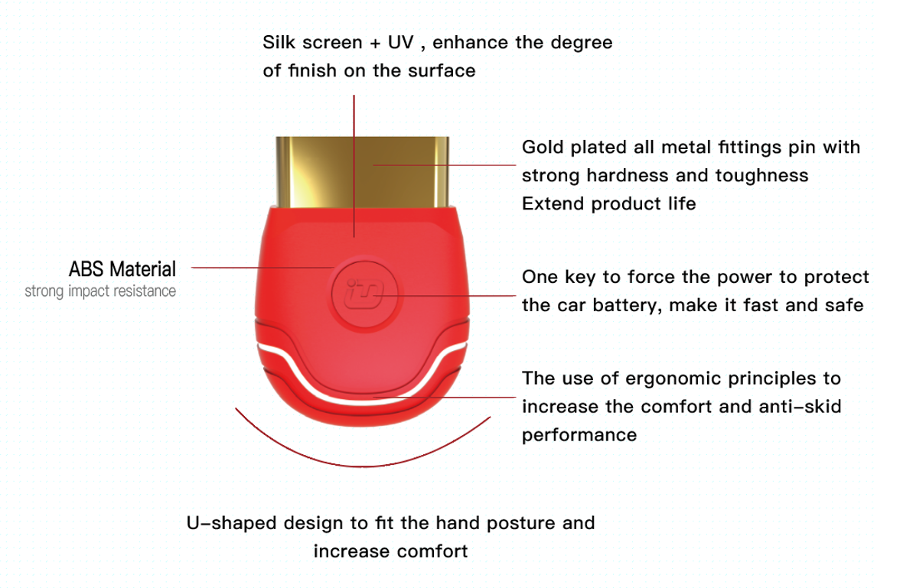
The Adapter, made of industrial grade materials, is strong and durable. The smart switch can force the power to protect the car battery. The smart light can prompt the communication information any time.

3. Software Feature

3.1 Function Introduction
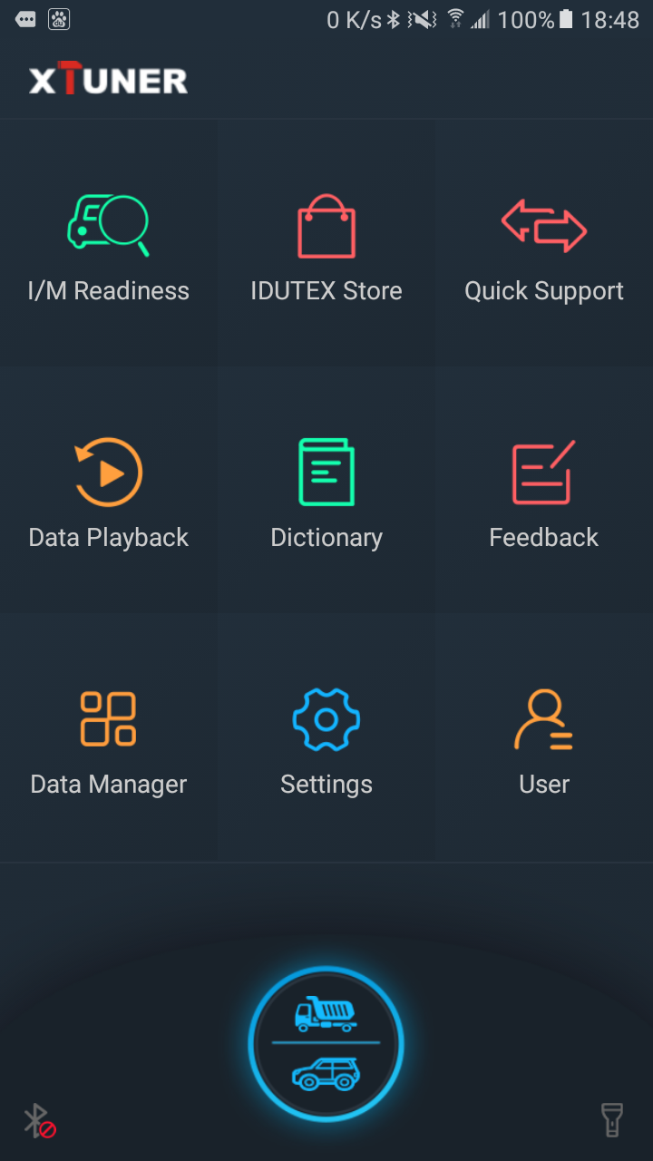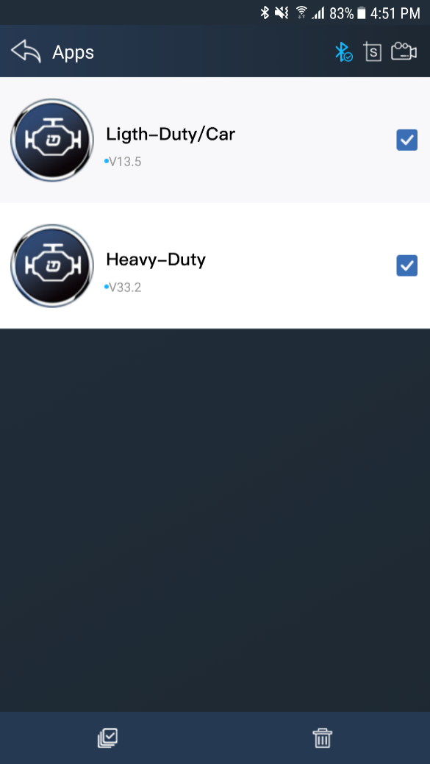
XTUNER CVD-16, there are 10 functions, DAS(commercial vehicle and passenger car), I/M Readiness, IDUTEX Store, Quick support, Data Playback, Dictionary, Feedback, Data Manager, Setting, User and etc.

3.2 Software Feature
1. Routine diagnosis for heavy duty vehicles from 1999 to newest utilizing SAE-J1939 and SAE-J1708 protocols.
2. Routine diagnosis for almost all cars, mini vans and light duty vehicle from 1996 to newest utilizing ISO9141, ISO14230, ISO15765, SAE-J1850 VPW and SAE-J1850 PWM.
3. The heavy-duty vehicle model and engine type can be auto detected.
4. OE Level Fault Code Information: display 99% of Heavy-Duty fault codes with detailed OEM level component and trailer descriptions.
5. Read and erase generic codes (P0, P2, P3 and U0), manufacturer specific codes (P1, P3 and U1), and pending codes for cars, mini vans and light duty.
6. Display DTC definition, freeze frame data, monitor and I/M readiness status (emissions), and vehicle information (VIN, CIN and CVN)
7. Read, store and playback live O2 sensor test data.
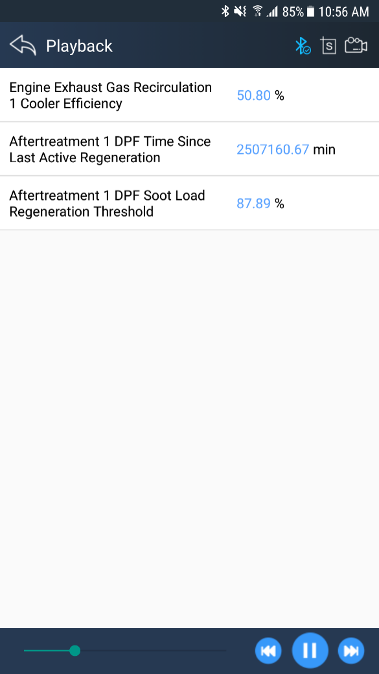
8. Read PCM live data stream, with professional graphic data Display, includes waveform and instrument mode.
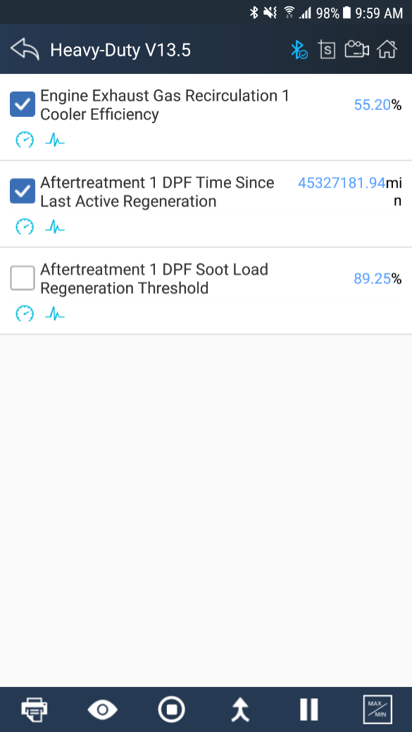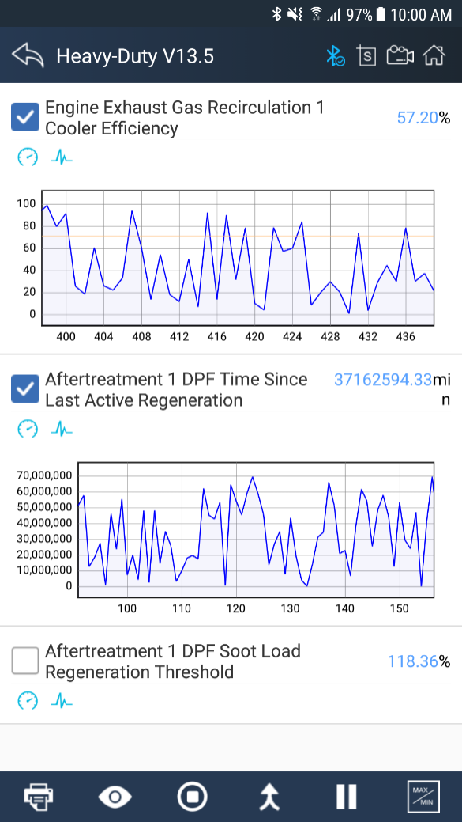
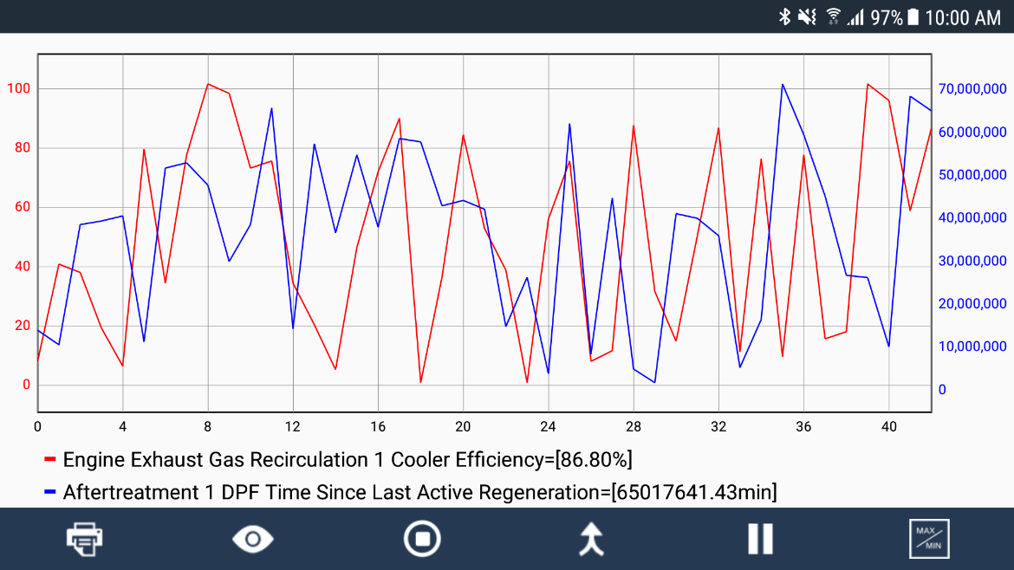
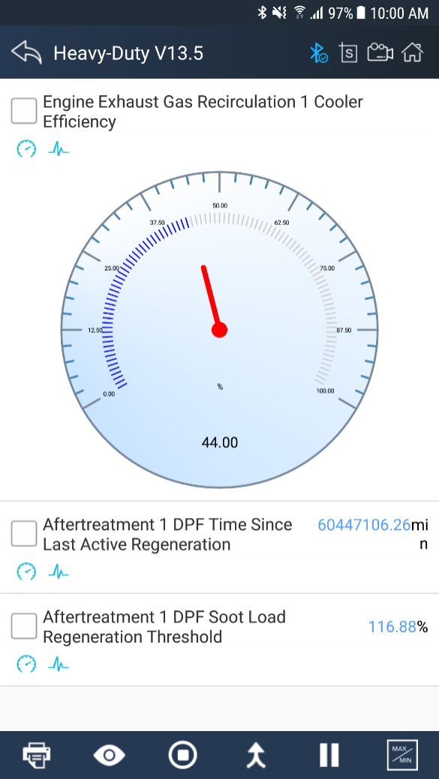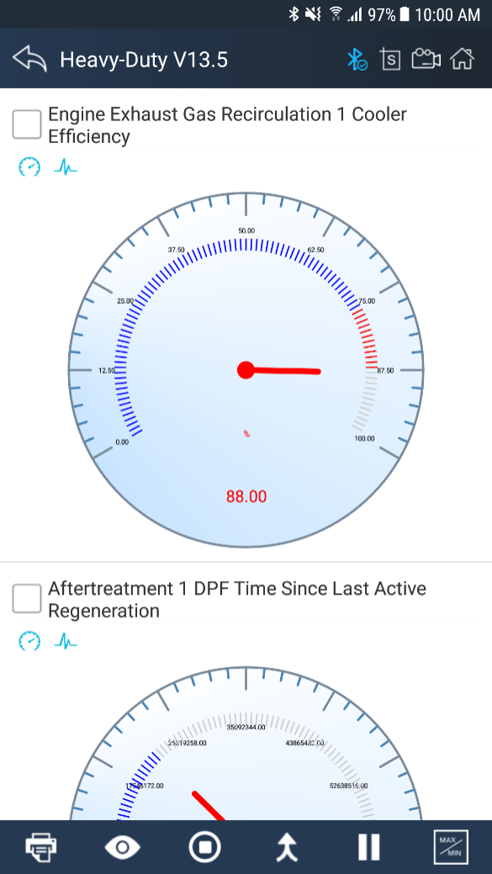
9. Enhanced OBDII Mode 6.
10. Support Multilanguage, includes English, German, French, Korean, Polish, Spanish, Italian, Portuguese, Polish, Russian and etc.
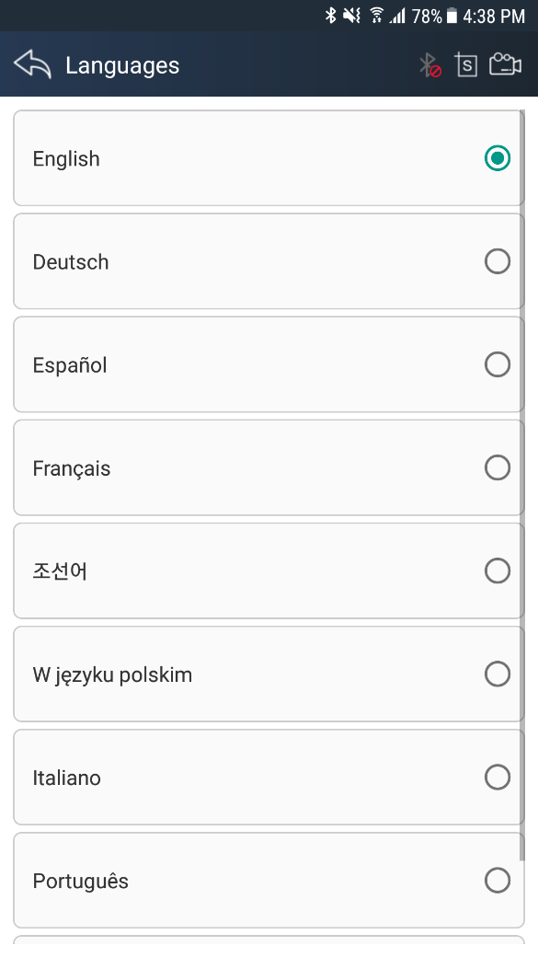
11. Support standard value of data stream for heavy duty vehicle.
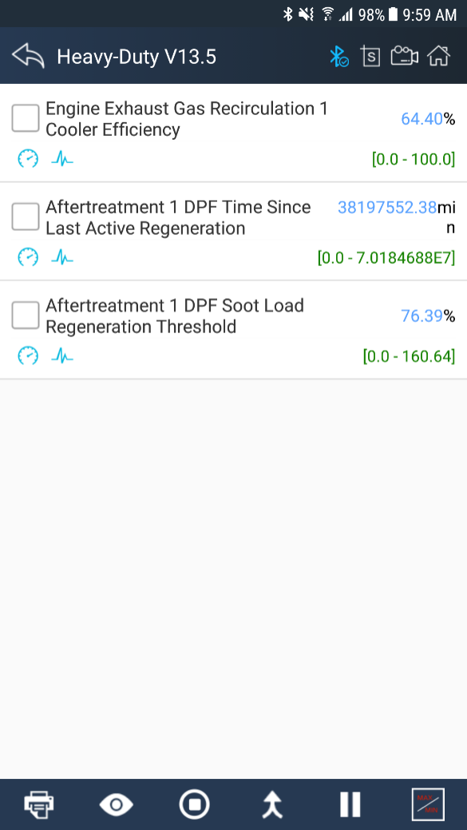
12. Support online and offline DTC query.
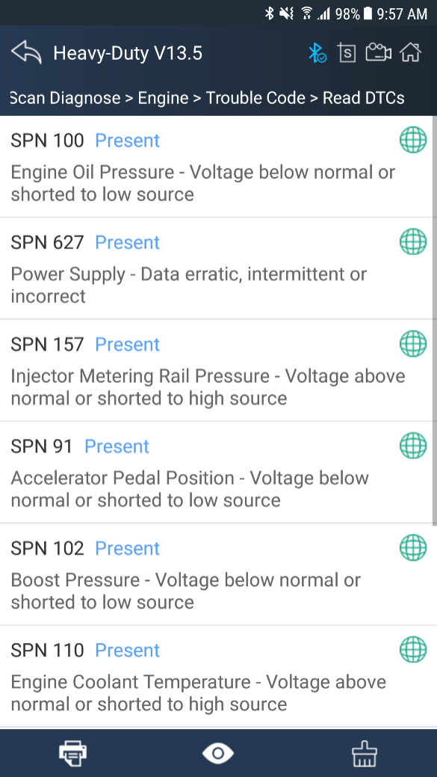
13. Support online dictionary.
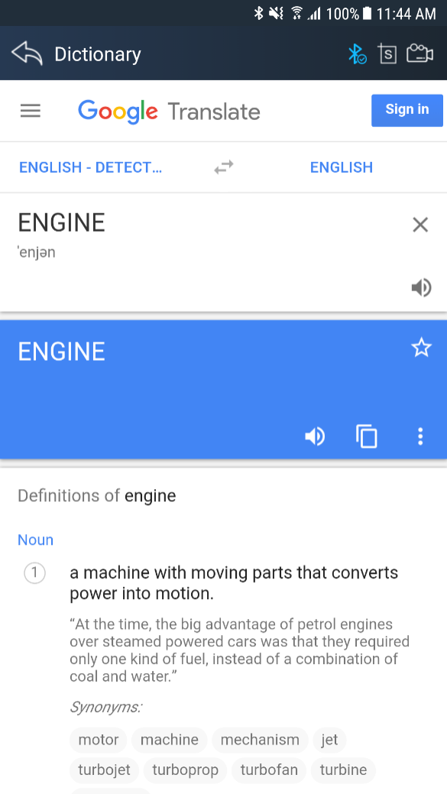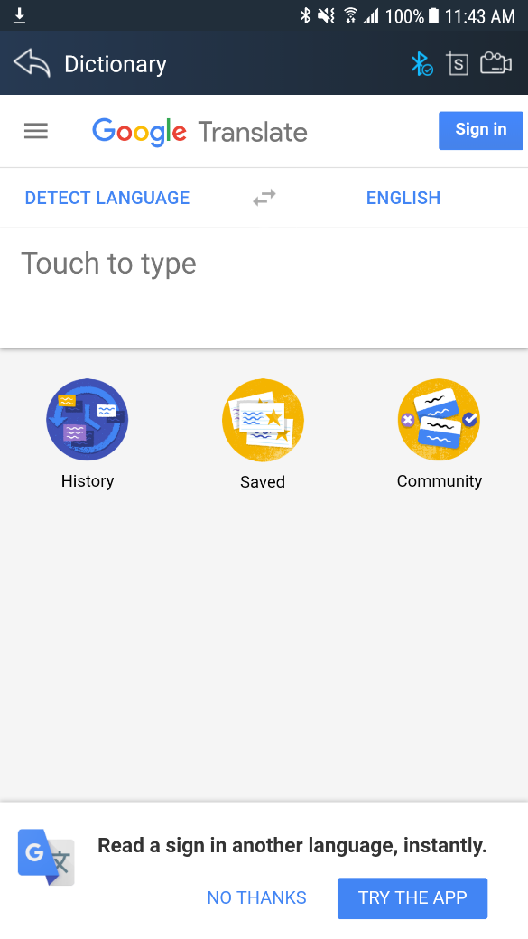
14. Support standard 6 pin and 9 pin diagnostic adapters.
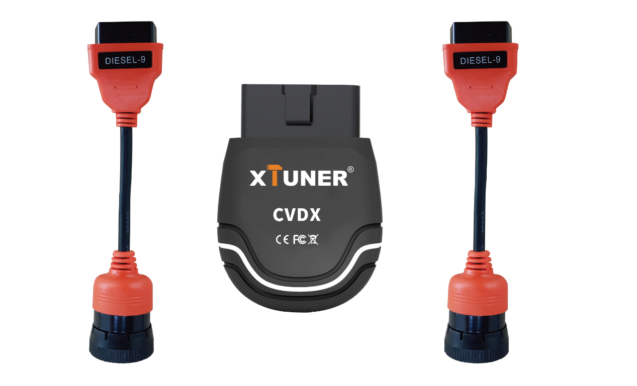
15. The Adapter, made of industrial grade materials, is strong and durable.
16. Support one-key power cut, one-key feedback, one-key update.
17. Software online updatable.

4. Code Coverage Introduction
Run XTUNER CVD16，The main interface will show:
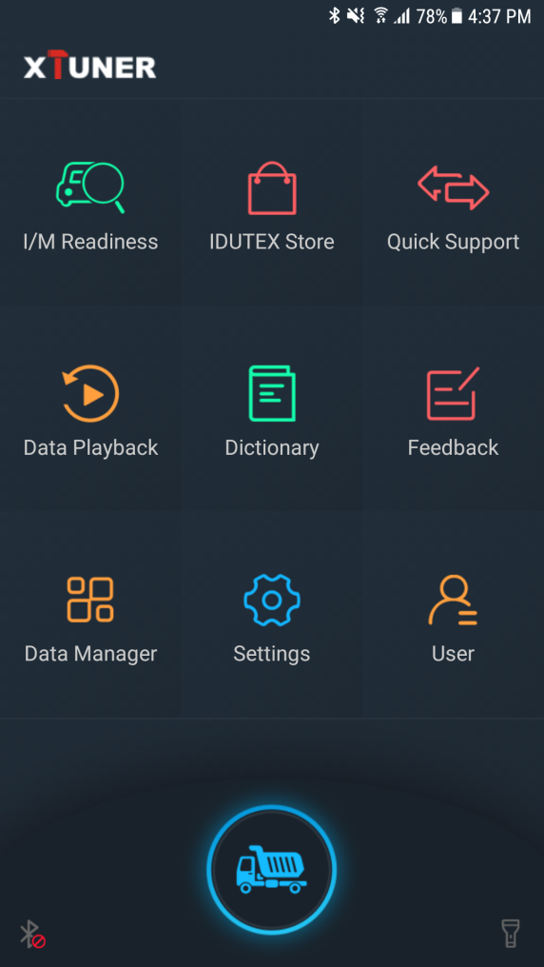

4.1 IDUTEX Store
● Automatic Wi-Fi updates available in new software releases by smart upgrade mode.
● Wi-Fi internet capability allows for wireless access throughout the workshop.
●Extremely easy-to-use with touch-screen operation and intuitive operation in the Android.
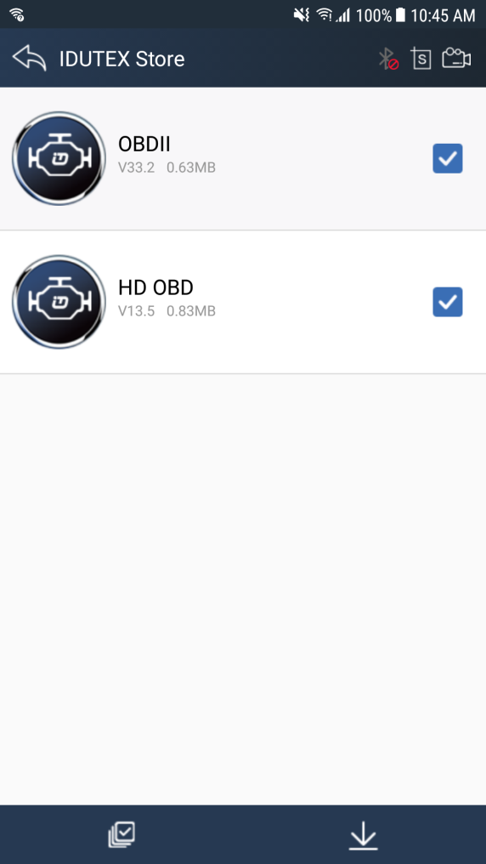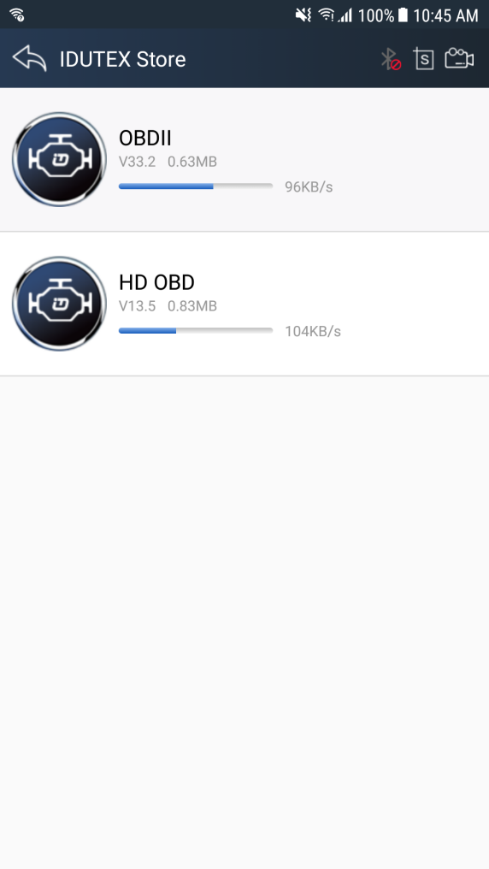

4.2Diagnosis Service System

4.2.2 Heavy-Duty Coverage
Vehicle Coverage：
Allison, Bendix, Caterpillar, Cummins, Detroit Diesel, Freightliner, Fuller, Haldex, International, John Deere, Mack, Mack 4, Mercedes Benz, Paccar, Pi, Psi, Takata, Volvo, Wabco, ZFMeritor, Kenworth, Sterling, Peterbilt, Western Star, Man, Scania, Renault, ERF, Foden, Seddon-Atikinson, Iveco, Daf, Sisu, Stery.
System Coverage：
Engine, Turbocharger, Transmission, Power Takeoff, Axle, Axle, Trailer, Brakes, Brakes, Trailer, , Instrument Cluster, Trip Recorder, Engine - Vehicle Mgt System, Fuel System, Engine - Cruise Control, Road Speed Indicator, Cab Climate Control, Cargo Refrigeration/Heating, Trailer, Suspension, Suspension, Trailer, Diagnostic System, Diagnostic System, Trailer, Electrical Charging System, Proximity Detector, Front, Proximity Detector, Rear, Aerodynamic Control Unit, Vehicle Navigation Unit, Vehicle Security, Multiplex, Communication Unit - Ground, Tires, Tires, Trailer, Electrical, Driver Information Center, Off-board Diagnostics, Engine Retarder, Cranking/Starting System, Transmission, Additional, Particulate Trap System, Vehicle Sensors to Data Converter, Data Logging Computer, Off-board Diagnostics #2, Communication Unit- Satellite, Off-board Programming Station, Engine #4 / Rear Axle Steering Controller, Engine #5 / Pneumatic System Controller, Engine #6 / Tires Control Unit, Vehicle Control Head Unit / Vehicle Management System #2, Vehicle Logic Control Unit / Vehicle Management System #3, Vehicle Head Signs, Refrigerant Management Protection and Diag., Vehicle Loc. Unit - Differential Correction, Front Door (Door #1) Status Unit, Middle Door (Door #2) Status Unit, Rear Door (Door #3) Status Unit, Annunciator Unit, Fare Collection Unit, Schedule Adherence Unit, Route Adherence Unit, Environment Monitor Unit / Auxiliary Cab Climate Control, Vehicle Status Points Monitor Unit, High Speed Communications Unit, Mobile Data Terminal Unit, Vehicle Proximity, Right Side, Vehicle Proximity, Left Side, Base Unit (Radio Gateway to Fixed End), Bridge from SAE J1708 Drivetrain Link, Maintenance Printer, Vehicle Turntable / Fifth Wheel Hitch Monitoring Device, Bus Chassis Identification Unit, Smart Card Terminal, Mobile Data Terminal, Vehicle Control Head Touch Screen, Silent Alarm Unit, Surveillance Microphone, Lighting Control Adminstrator Unit, Tractor/Trailer Bridge, Tractor Mounted, Tractor/Trailer Bridge, Trailer Mounted, Collision Avoidance Radar, Tachograph, Driver Information Center #2, Driveline Retarder, Transmission Shift Console Primary, Parking Heater, Weighing System, Axle Group #1 / Vehicle, Communication Unit - Cellular, Safety Restraint System, Intersection Preemption Emitter, Instrument Cluster #2, Engine Oil Control System, Entry Assist Control , Idle Adjust System, Passenger Counter Unit , Fuel Tank Monitor, Axles, Trailer , Diagnostic Systems, Trailer , Brakes, Trailer , Forward Road Image Processor, Body Controller, Steering Column Unit, Tires, Trailer , Brake Stroke Alert Monitor, Tractor, Safety Restraint System #2, Transmission #2, Shift Console - Primary, Shift Console - Secondary, Power Takeoff - (Main or Rear), Axle - Steering, Axle - Drive , Brakes - Steer Axle, Retarder - Engine, Retarder - Driveline, Cruise Control, Steering Controller, Suspension - Steer Axle, Passenger/Operating Climate Control, Alternator/Electrical Charging System, Aerodynamic Control, Vehicle Navigation, Electrical System, Starter System, Tractor-Trailor Bridge #1, Auxiliary Valve Control, Hitch Control, Power Takeoff (Front or Secondary), Off Vehicle Gateway, Virtual Terminal (in cab), Management Computer, Cab Display, Retarder, Exhaust, Engine , Headway Controller, On-Board Diagnostic Unit, Endurance Braking System, Hydraulic Pump Controller, Suspension - System Controller, Pneumatic - System Controller, Cab Controller - Primary, Cab Controller - Secondary, Tire Pressure Controller, Ignition Control Module, Ignition Control Module #2, Seat Controls, Lighting - Operator Controls, Rear Axle Steering Controller, Water Pump Controller, Passenger-Operator Climate Control #2, Transmission Display - Primary, Transmission Display - Secondary, Exhaust Emission Controller, Vehicle Dynamic Stability Controller, Oil Sensor, Suspension - Stability Controller #2, Information System Controller, Ramp Control, Clutch/Converter Unit, Auxiliary Heater, Auxiliary Heater #2, Engine Value Controller, Chassis Controller, Propulsion Battery Charger, Communications Unit, Cellular, Communications Unit, Satellite, Communications Unit, Radio, Fan Drive Controller, Seat Control #2, Parking Brake Controller, Aftertreatment System Gas Intake, Aftertreatment System Gas Outlet, Cab Display #2, DPF Controller, Atmospheric Sensor, Powertrain Control Module, Power System Manager,etc.
Function Coverage：
System Info., Read DTC, Clear DTC, Data List, I/M Readiness.

4.2.3 Ligth-Duty/Car Coverage
Vehicle Coverage：
All the passenger cars.
Functions covered:
Trouble Code, System Status, Readiness Code, Powertrain Freeze Data, Current Powertrain Diagnostic Data, O2 Monitoring Test, On-Board Monitoring Test, Component Test, Vehicle Information.

4.3 Settings

4.3.1 System info
Automatically identify XTUNERand XTUNERversion information, when connection has problem(Wi-Fi or Bluetooth), and it can’t read XTUNERHardware version, usually, it shows as“Unknown”or“---”;If the connection is OK, it shows hardware version. As the picture shows:
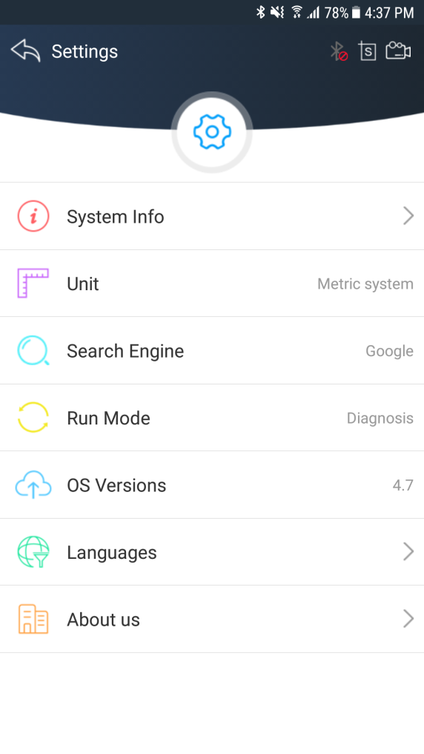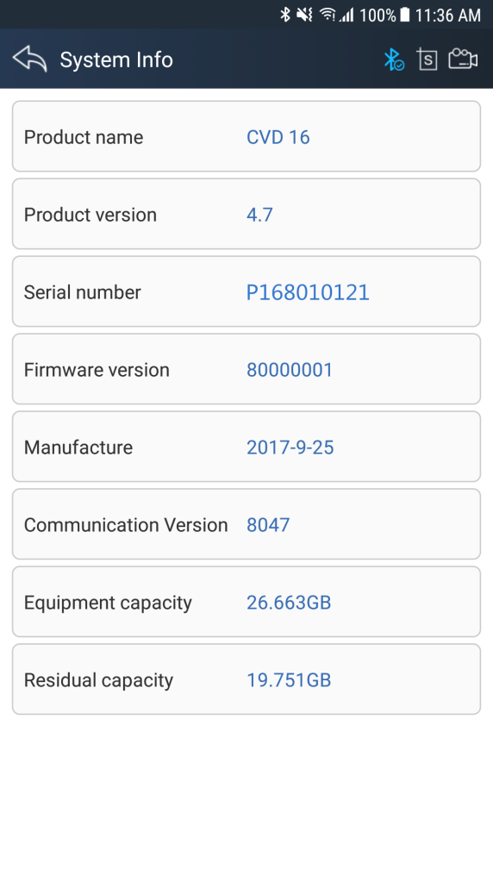

4.3.2Unit
Unit switch between Metric and Imperial system:
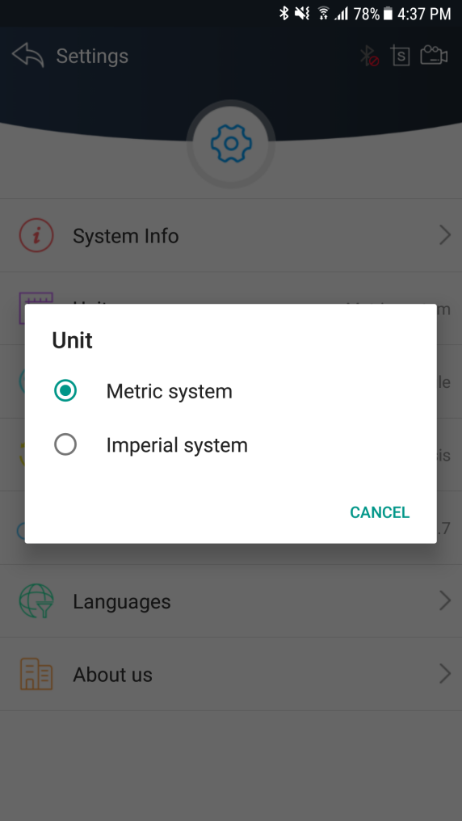

4.3.3 Search Engine
This feature is based on different browser on your mobile APP and you can set different search engine.

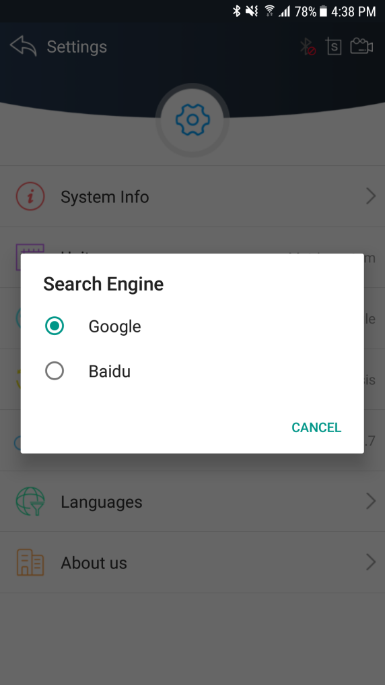

4.3.4Run Mode
When XTUNER CVD16 is not connected, you can simulate the operation of the vehicle through the operating mode, as shown in the following figure:

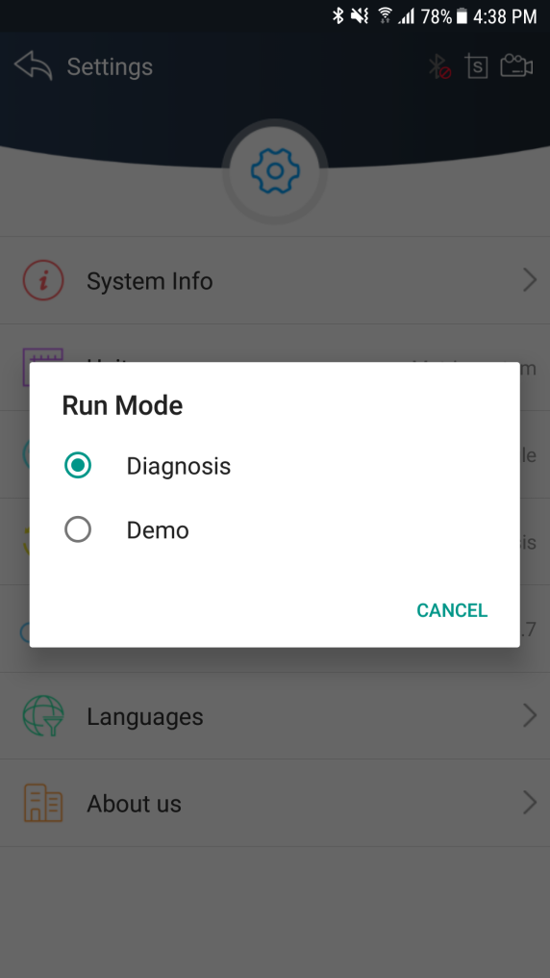

4.3.5OS Versions
If there i a new version, it can automatically prompt to update.

4.3.6Languages
Choose the language you need, as the picture shows:
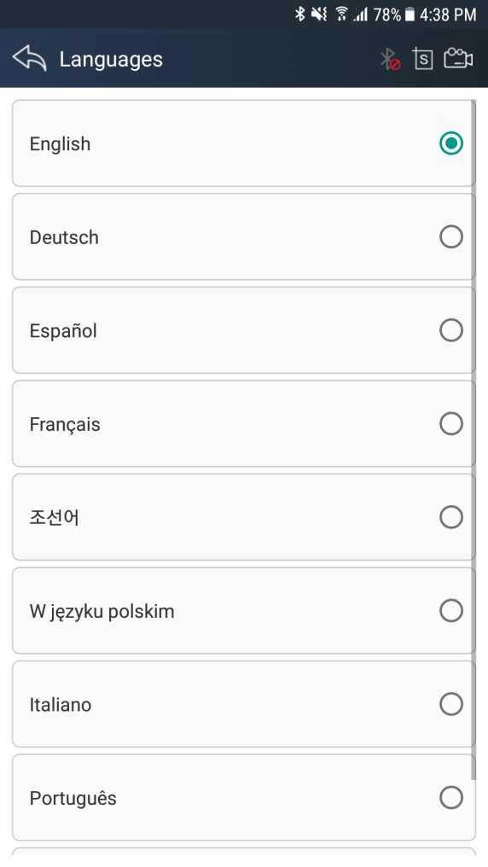
Language coverage: Support muti-language include English, German, French, Korean, Spanish, Italian, Portuguese, Polish, Russian.

4.3.7About US
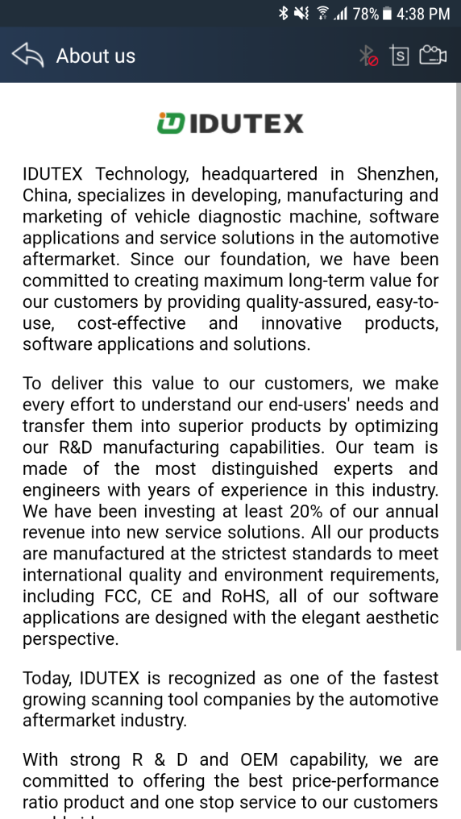

4.4Dictionary
You can use this function to query automotive terms, abbreviations or commonly used English sentences.
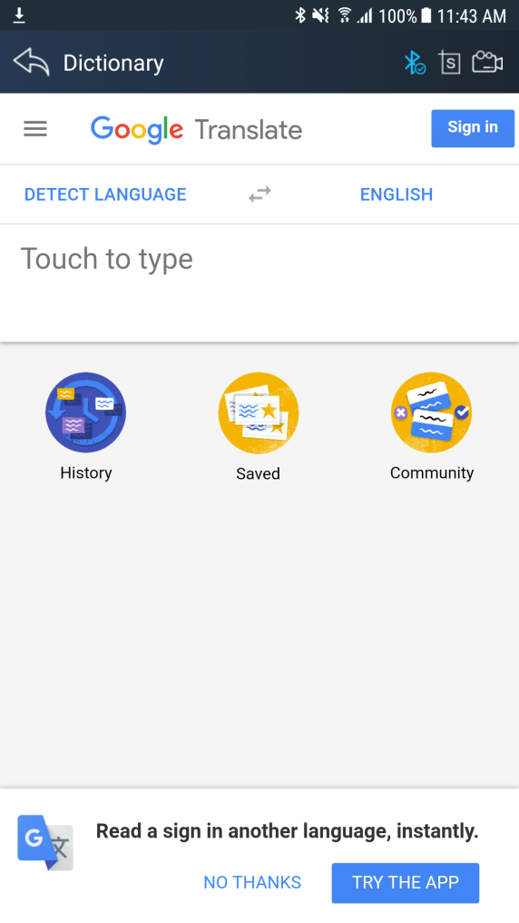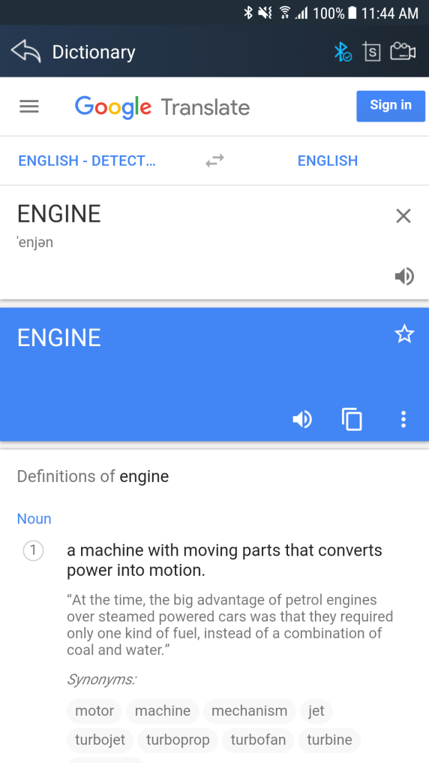

4.6Example

4.6.1 Bluetooth pairing
Before communication, please connectXTUNER CVD16with the car. And then please pair with Bluetooth.
- How to connect Bluetooth?
1.Please loginIDUTEX Store, and return to the main interface of XTUNER CVD16.
2.Please clickto turn on Bluetooth.
3. click the serial number for pairing.
4.Please enter the pairing code: 1234 or 0000.
5.Please click OK.
After connection, the indication light turn on red.Please check the connection of Bluetooth, if connect successfully, the will turn to , andthe VCI indication light will turn to blue.

4.6.2 Communication
After Bluetooth connection is successful, click "" to enter the diagnostic service system, please select function to start the diagnosis.
Take Heavy-Duty as an example:
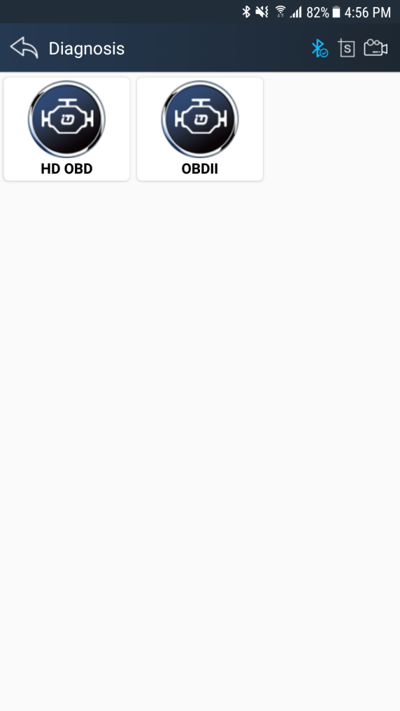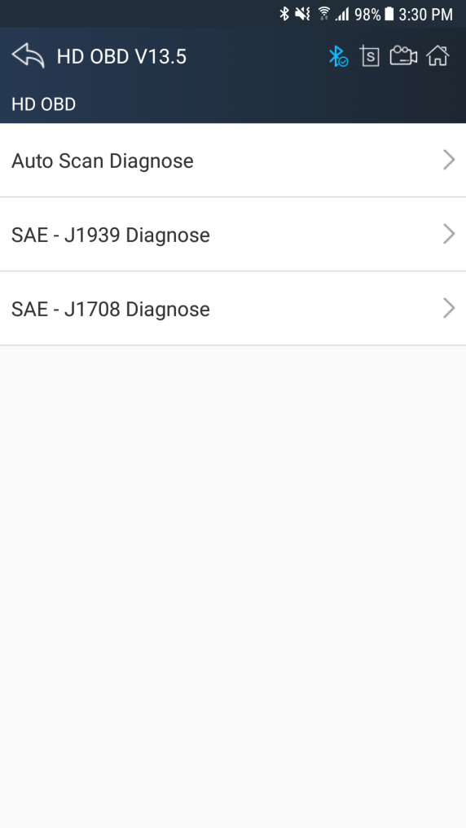
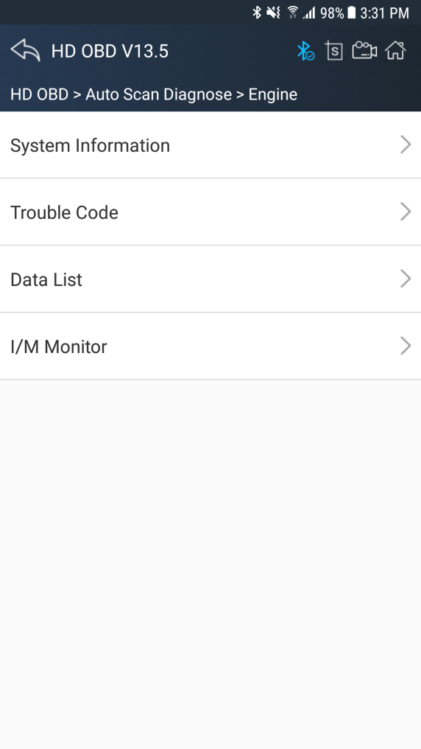

4.6.3 Read ECU Information
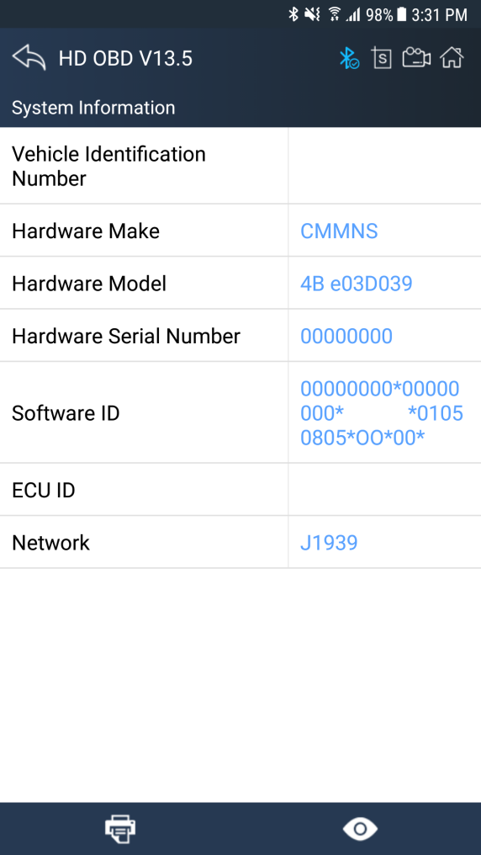

4.6.4 Read DTCs
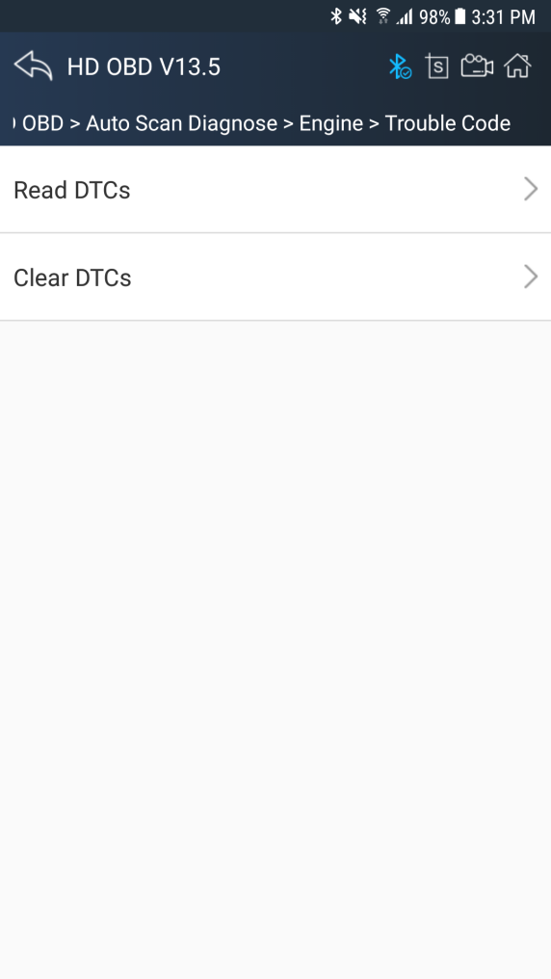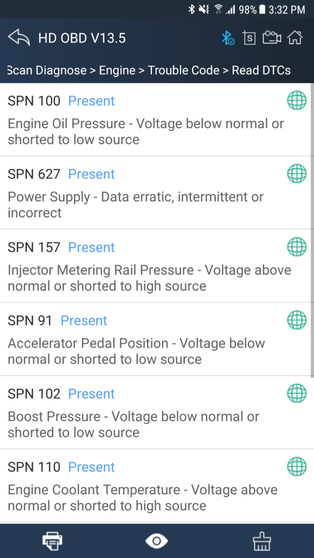

4.6.5 Erase DTCs
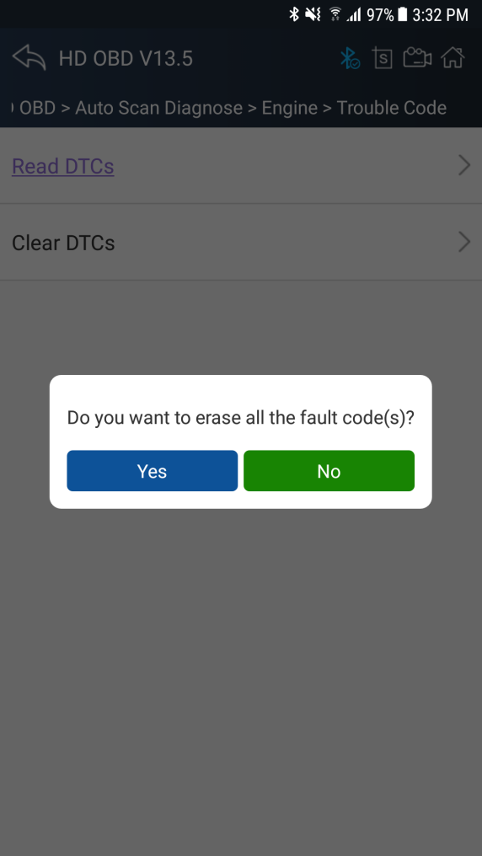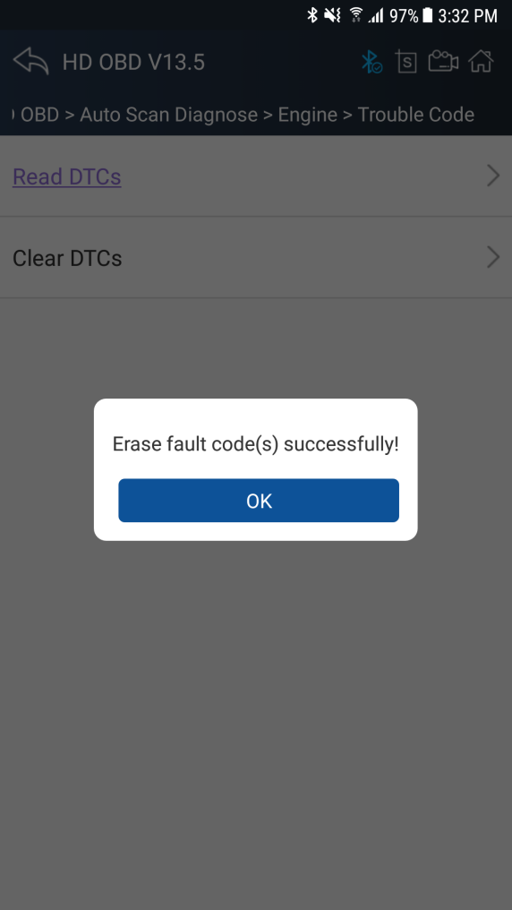

4.6.6 Data List
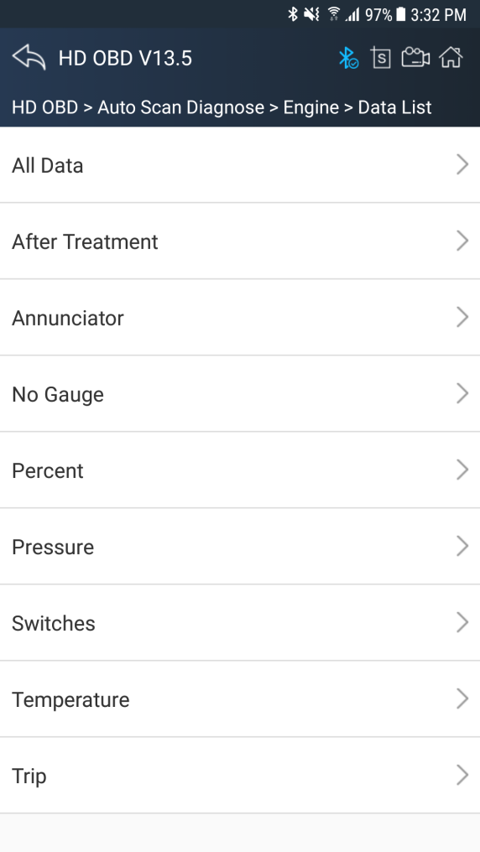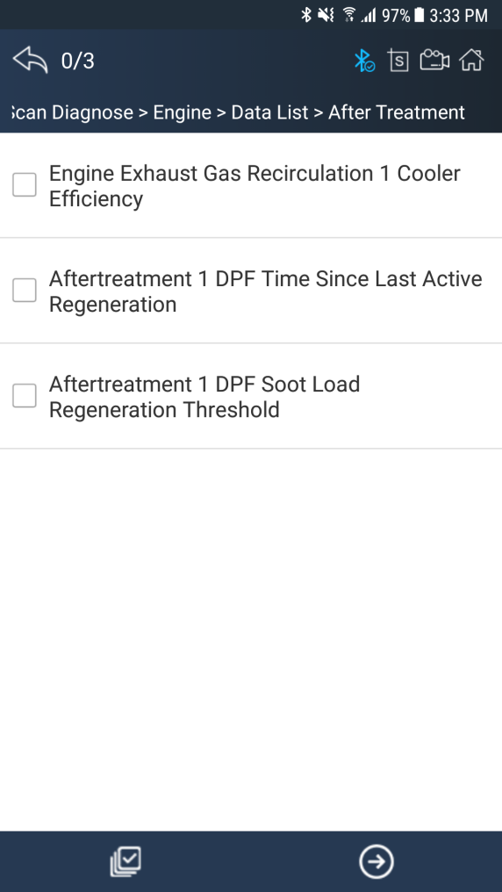
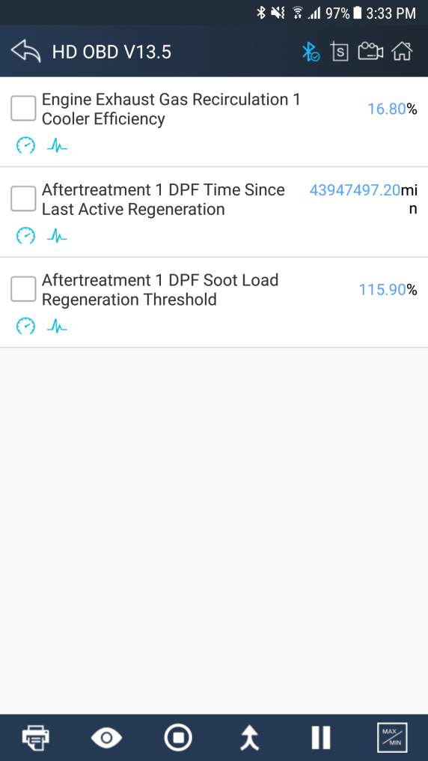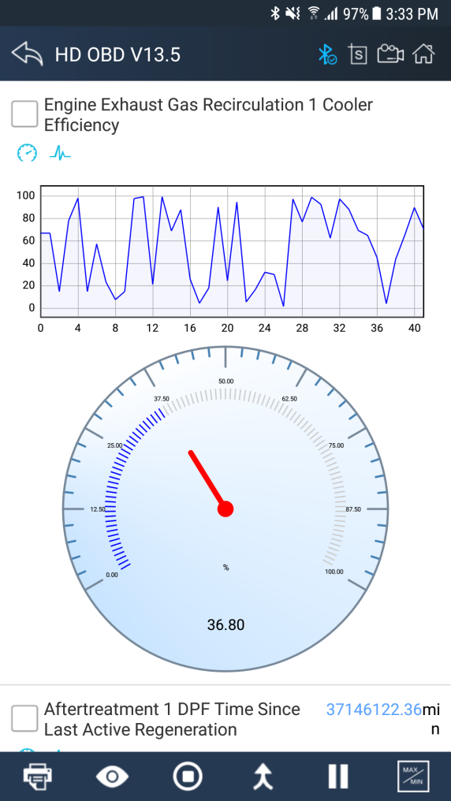
Click the button to view data reference value, until to click the button to turn off data reference mode:
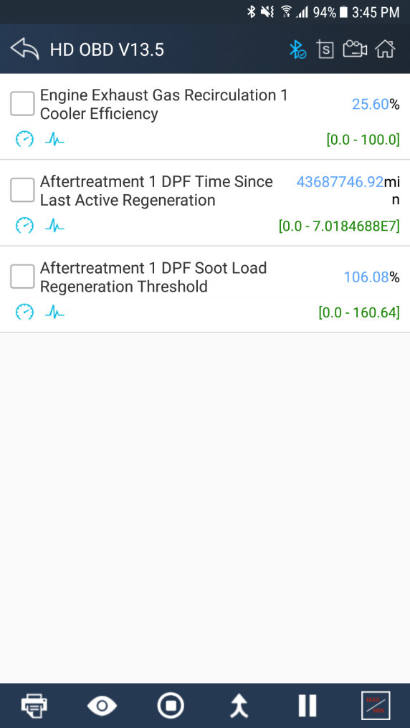
Click the button to start data recording, until to click the button to stop recording:
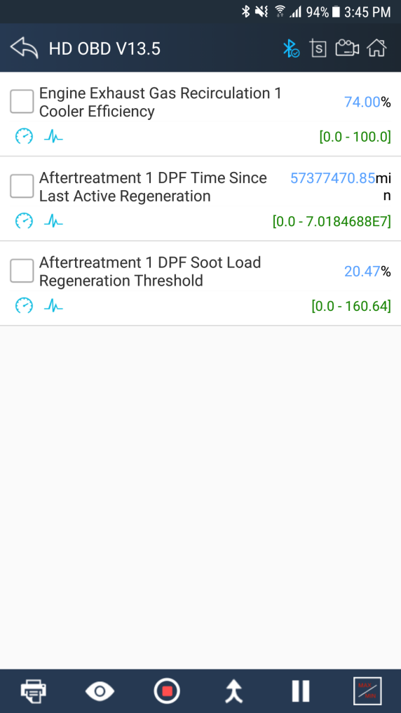
Please chick the button to select the data stream you want, click the button, vertical screen will show the dynamic effect of data stream.
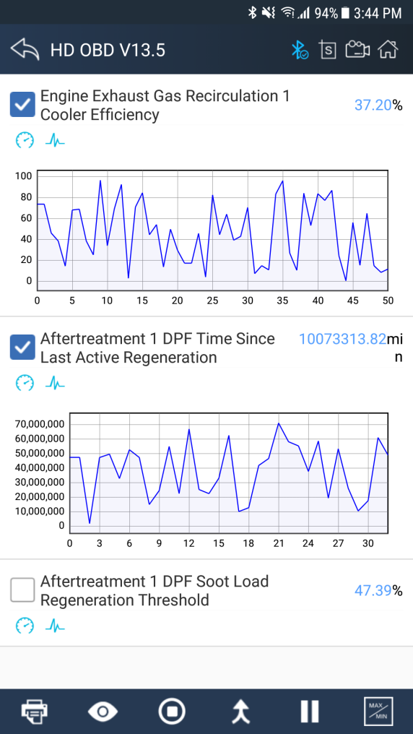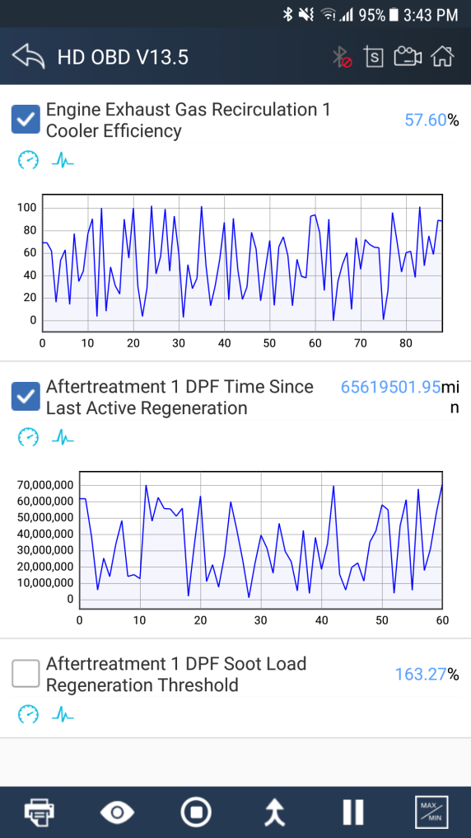
Please chick the button to select the data stream you want, click the button, horizontal screen will display dynamic effects ofsuperimposed waveform for data stream.
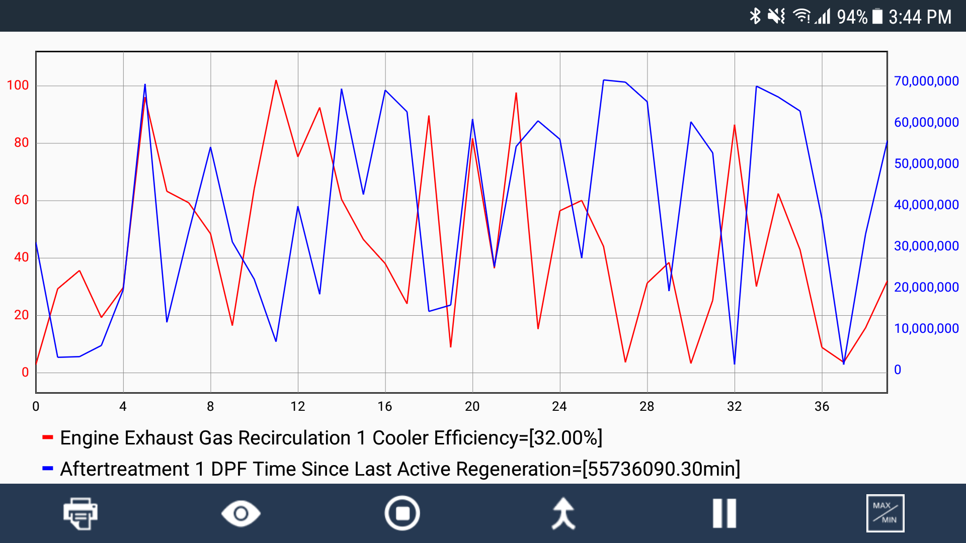

4.6.7I/M Readiness
I/M Readiness is a useful function used to check if all monitors are PASS, FAIL or N/A. The vehicle’s computer performs tests on the emission system during normal driving conditions. After a specific amount of drive time (each monitor has specific driving conditions and time required), the computer’s monitors decide if the vehicles emission system is working correctly.
When the monitor’s status is:
●PASS - vehicle was driven enough to complete the monitor.
● FAIL - vehicle was not driven enough to complete the monitor.
● N/A - vehicle does not support that monitor.
Below is an example:
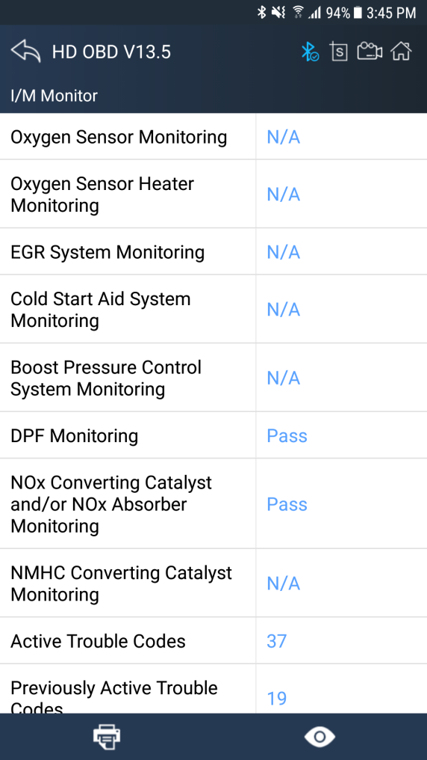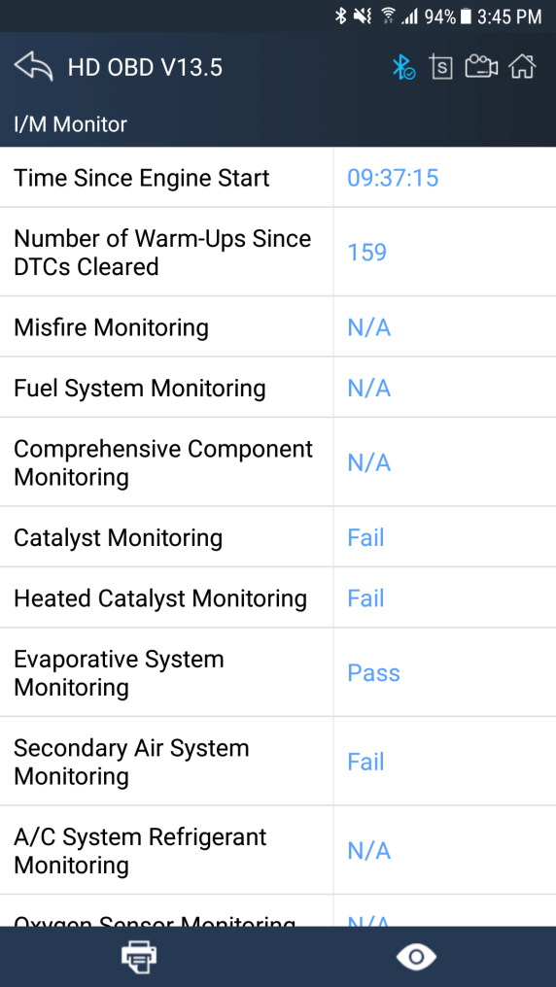

There are two ways to retrieve I/M Readiness Status data:
● One-click I/M readiness key
● Typical way: select I/M Readiness from Diagnostic Menu
NOTE:
● To review I/M Readiness status, make sure that the ignition key is switched to ON with theengine off.
● Not all monitors are supported by all vehicles.

4.7 Screenshot
Chick to Capture, save and print screenshotanytime and anywhere.
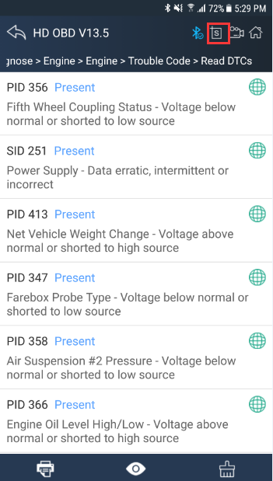
The screenshot files save at the path:
My fileI/Internal storage/IDUTEX/CVD16/UserData/Screenshots
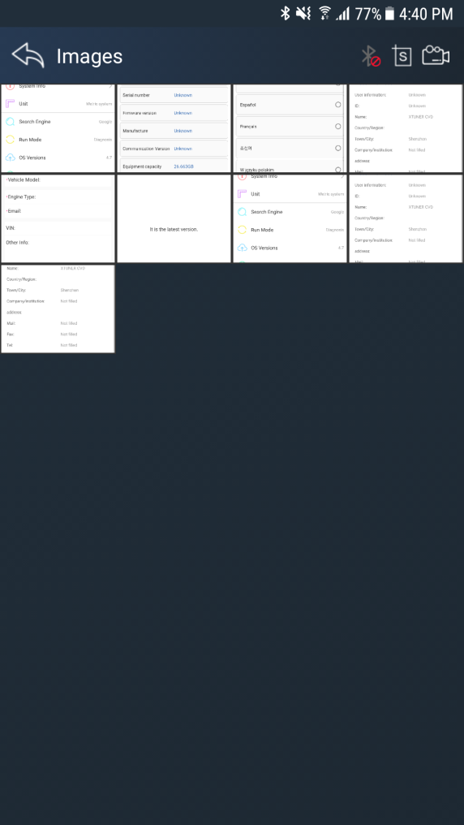

4.8Save
Using the saving function to generate the corresponding diagnostic report document for the vehicle diagnostic data, it greatly facilitates the diagnosis and management of the diagnosis and management of the diagnostic data.
Click the buttonto save the diagnostic report .
Click the button to view the diagnostic report , as the picture show:
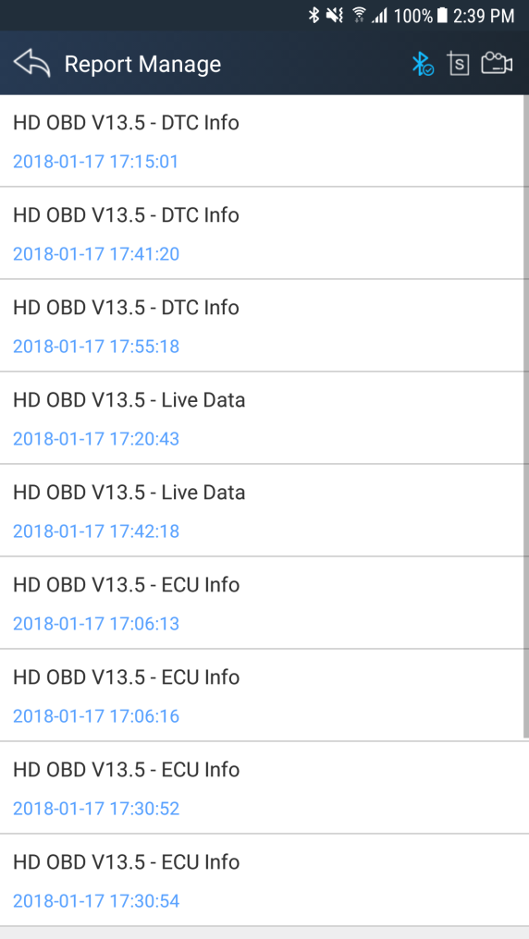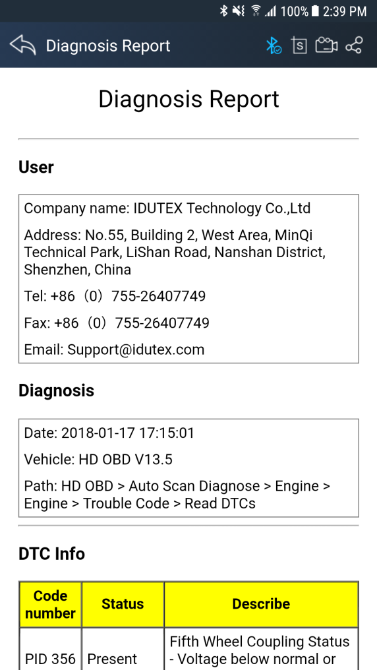

4.9Screen recording
Click the button to start the screen recording, click again to stop the screen recording. Use the function to recordXTUNER operation and generate the appropriate video files, The video can be checked in video management.

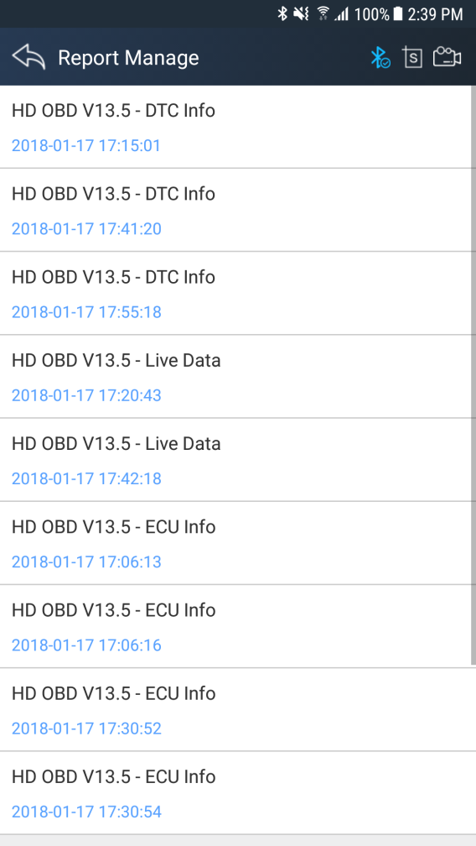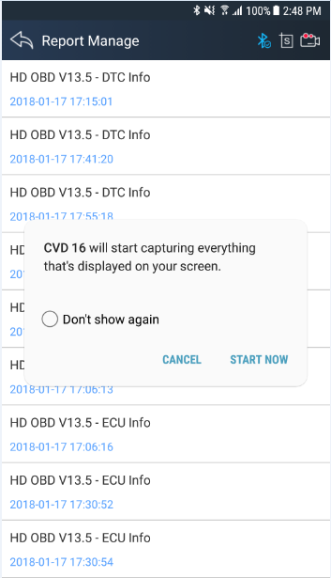

4.10Data Playback
You can quickly browse or delete the video of the diagnostic data you have recorded here.
Click the video to browse the video. Click the button to delete the video.

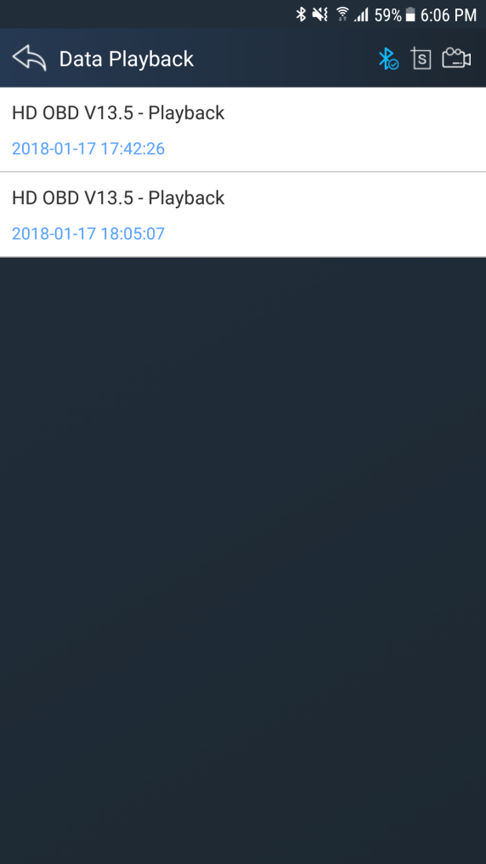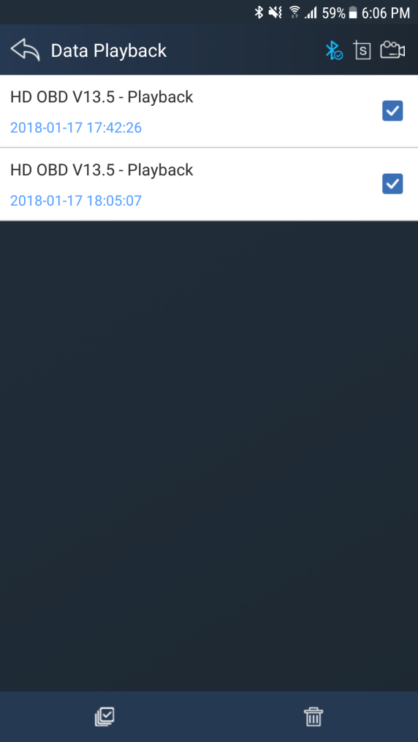

4.12Feedback
The information of diagnostic software problems can be uploaded to the manufacture by this function. It helps the engineers to fix the bugs quickly.
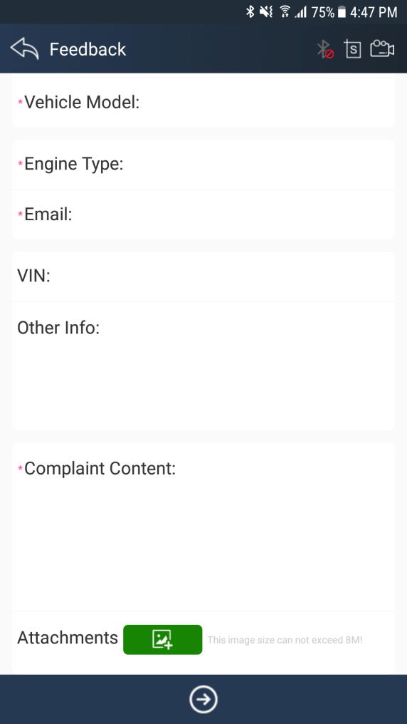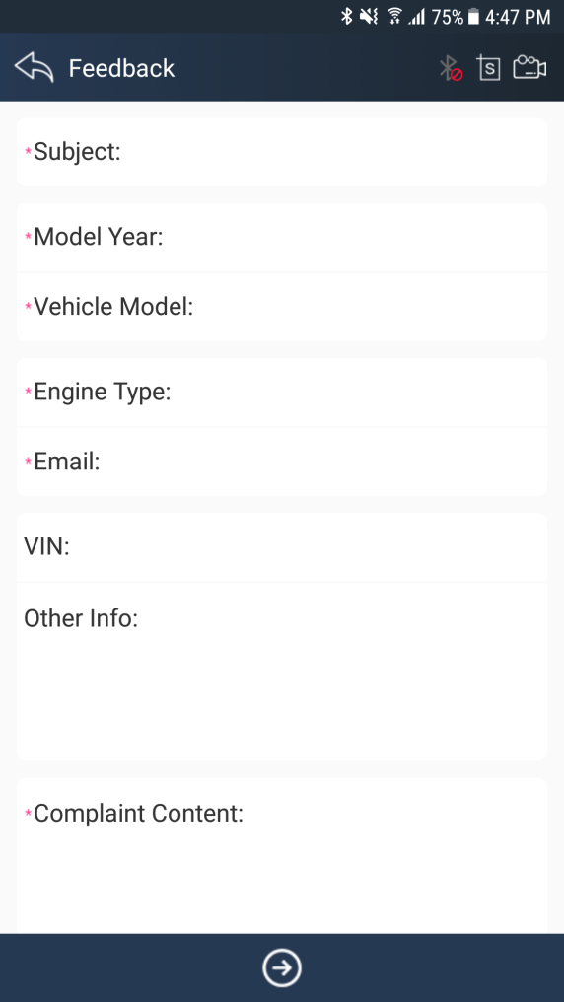

NOTE: With * information is required; the attachments size cannot exceed 8MB.

4.13Data Management

4.13.1 Image Management
Here you can browse or delete the Images.
Click the image to browse the picture. Click the button to delete the picture.

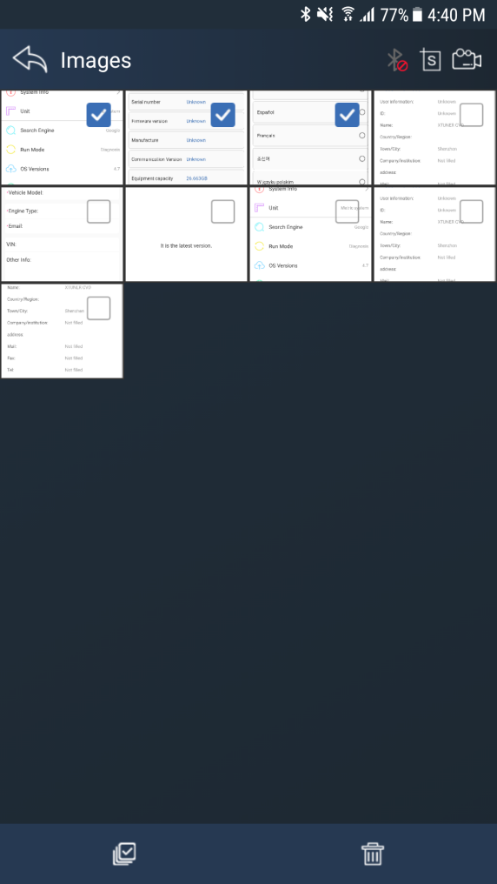

4.13.2 APP Management
Users can deletethe diagnostic software here, one by one or all-selected delete.Click the button to delete the diagnostic software.

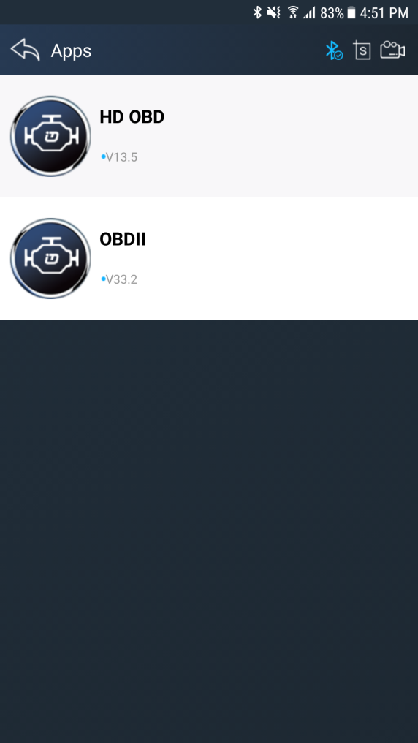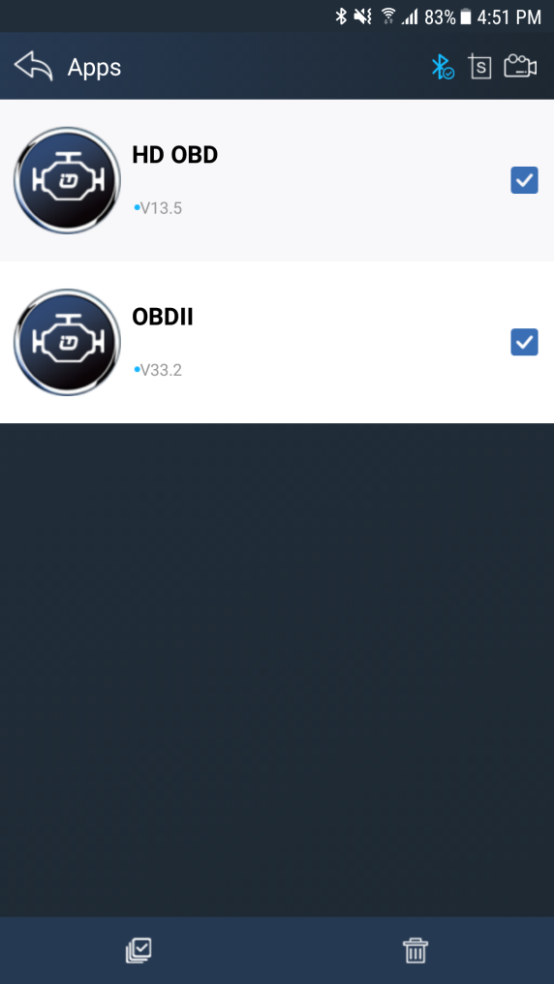

4.13.3 Video Management
Users can not only browse video but also delete video, including single deletion, multiple deletions, or all deletions.
Click the Video to browse the Video. Click the button to delete the Video.

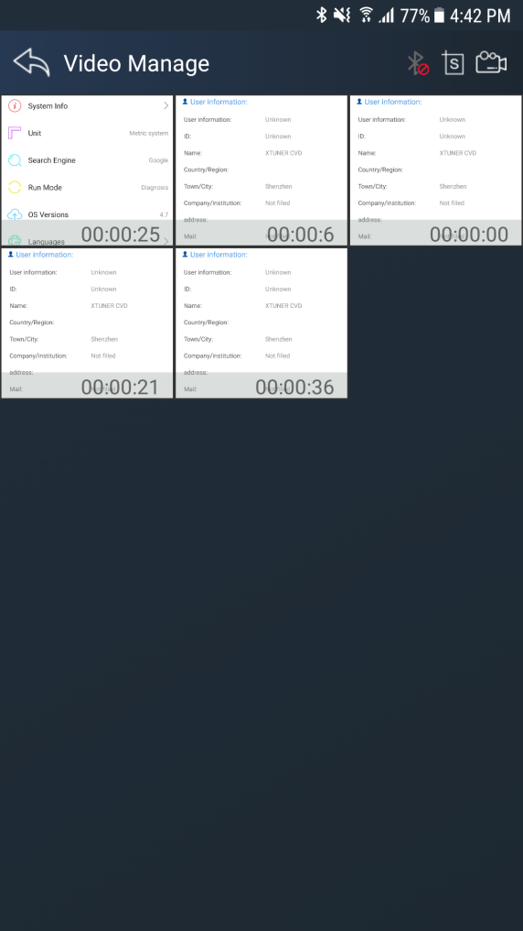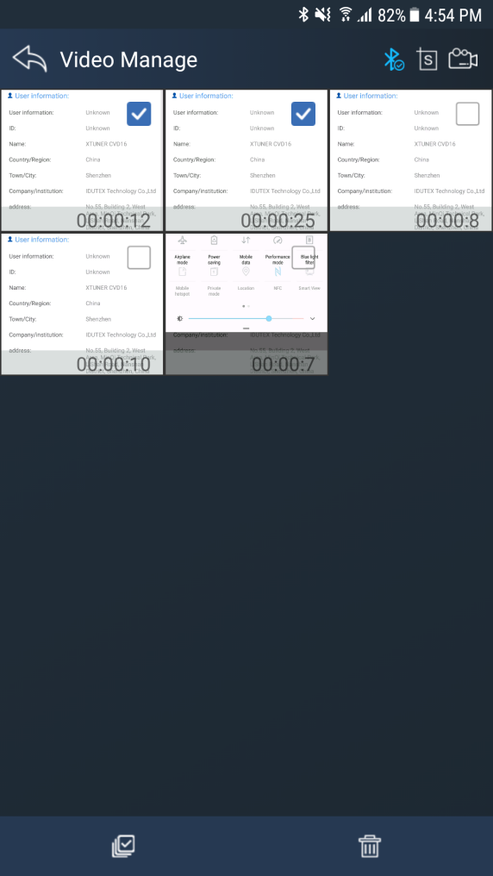

4.13.4 Report Management
Users can not only browse report but also delete report, including single deletion, multiple deletions, or all deletions.
Click the Report to browse the Report. Click the button to delete the Report.

4.14 User Management
Input workshop information, and Click the button to change the information.
chick the button to save the information.

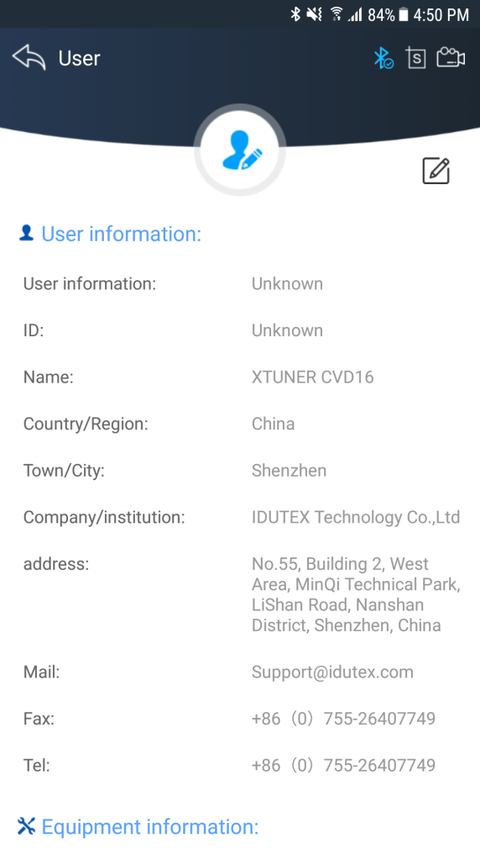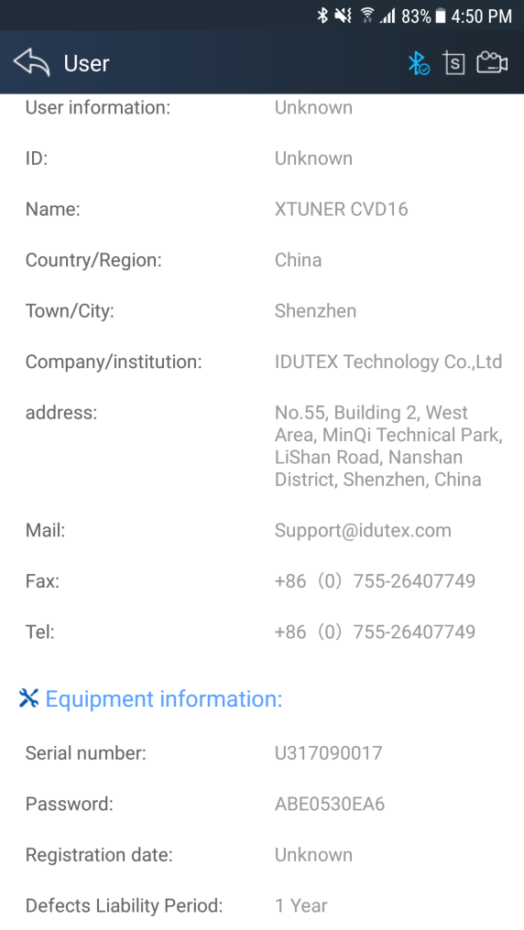

4.15 Quick Support
Run “Quick Support”to receive remote support.
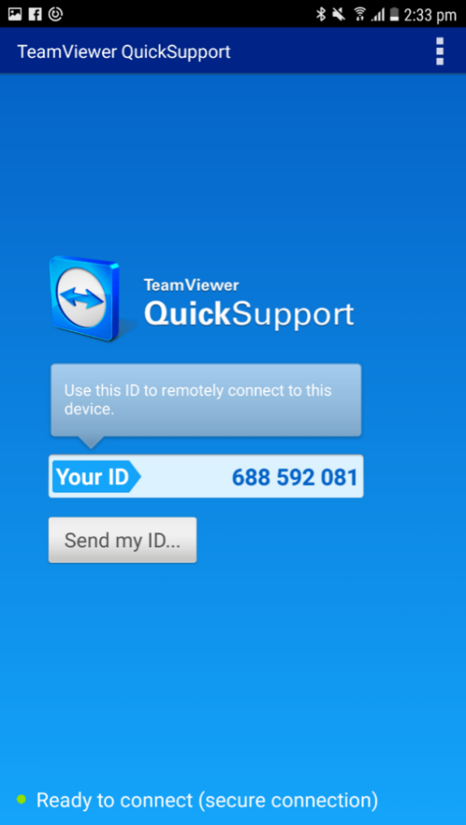

5. Products Website
Please focus on our website www.IDUTEX.com for the updating information and other news.

6. Warranty
XTUNERCVD16 software is free updating within 1 year from the date of product activation.

